Encircle OMS Design Document

Hold:

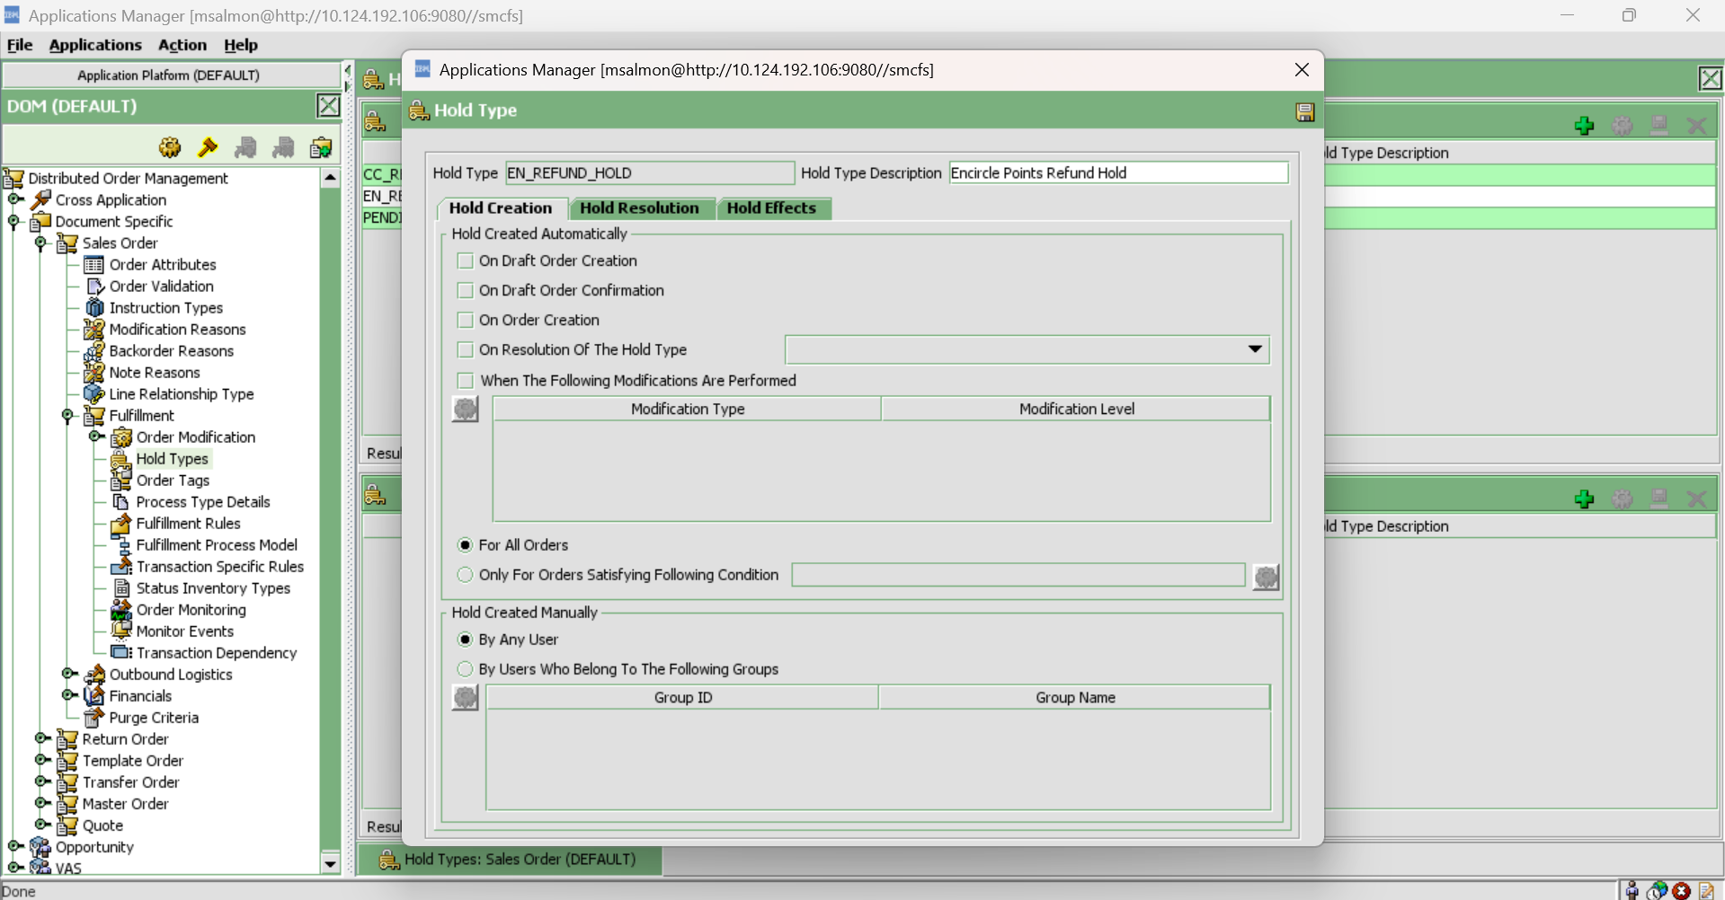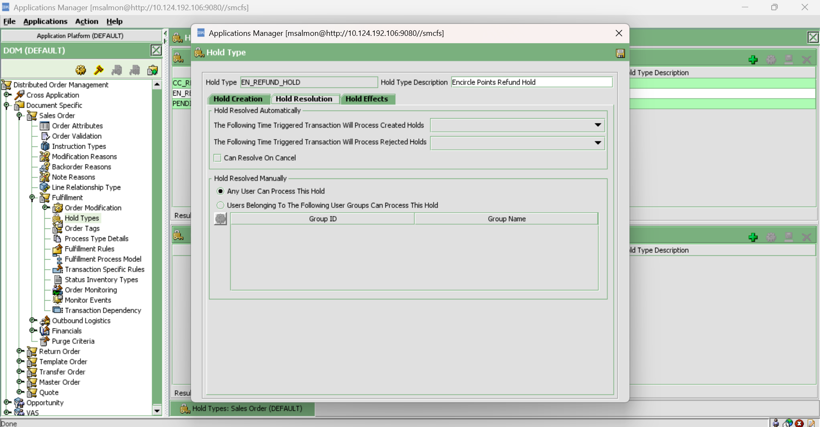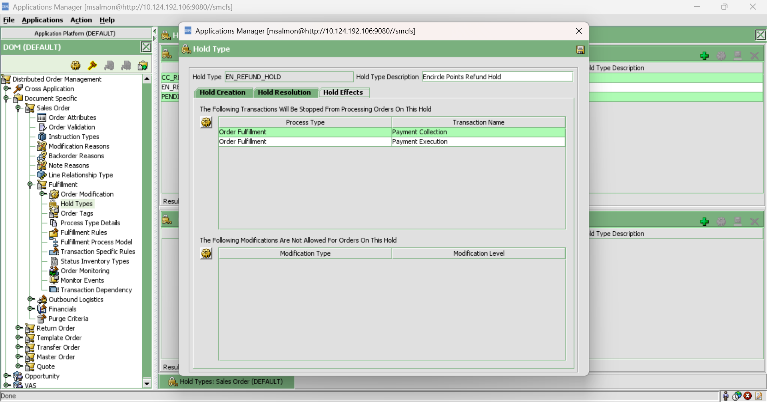

Encircle reversal configurations:

Order Fullfillment -> Change Order -> On Cancel -> IBD_CancelOrder ->

IBD_PostCancelMsg

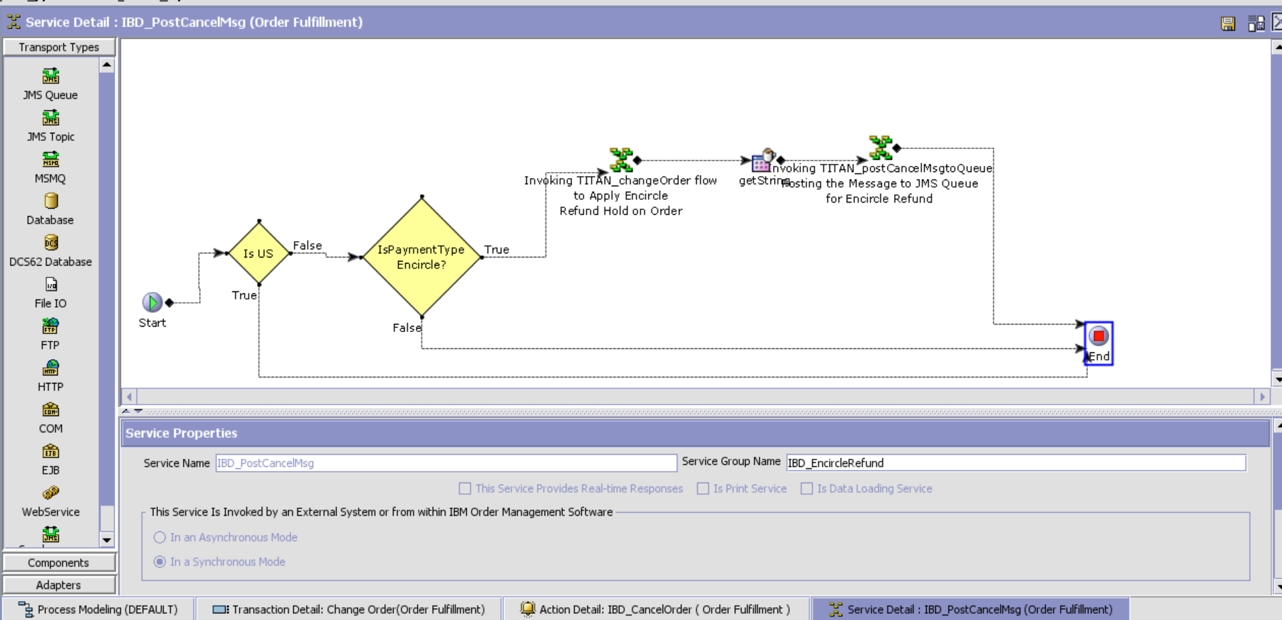

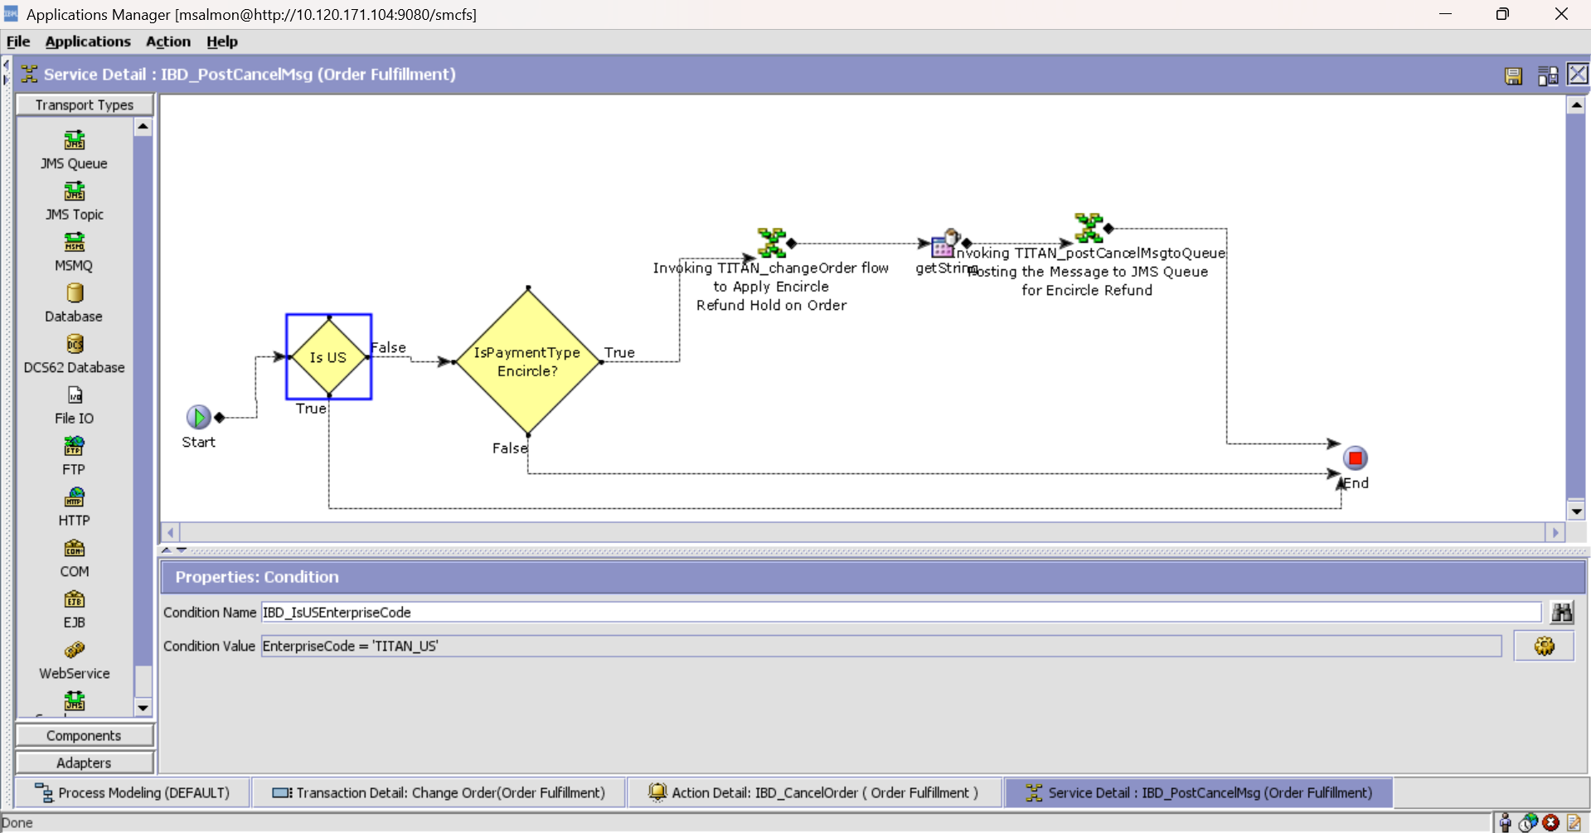

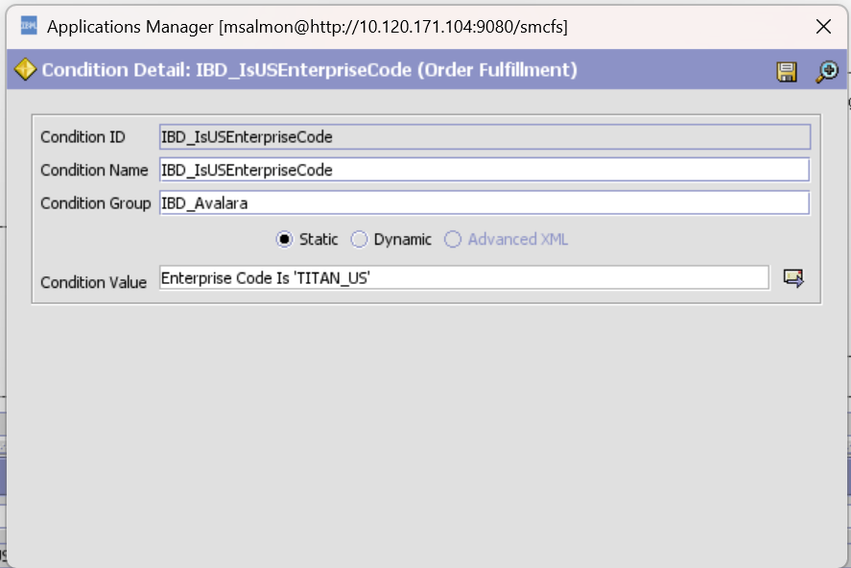

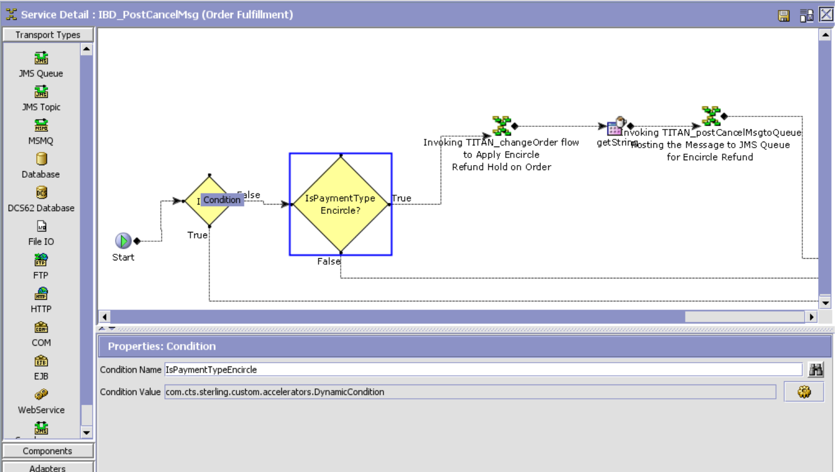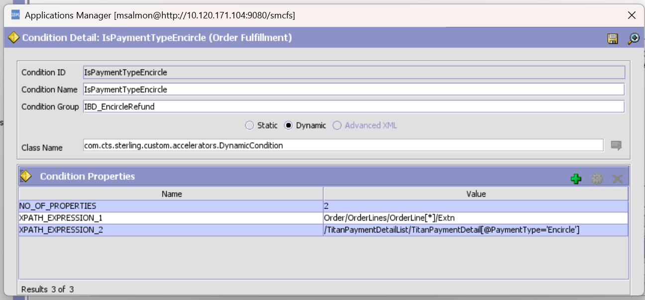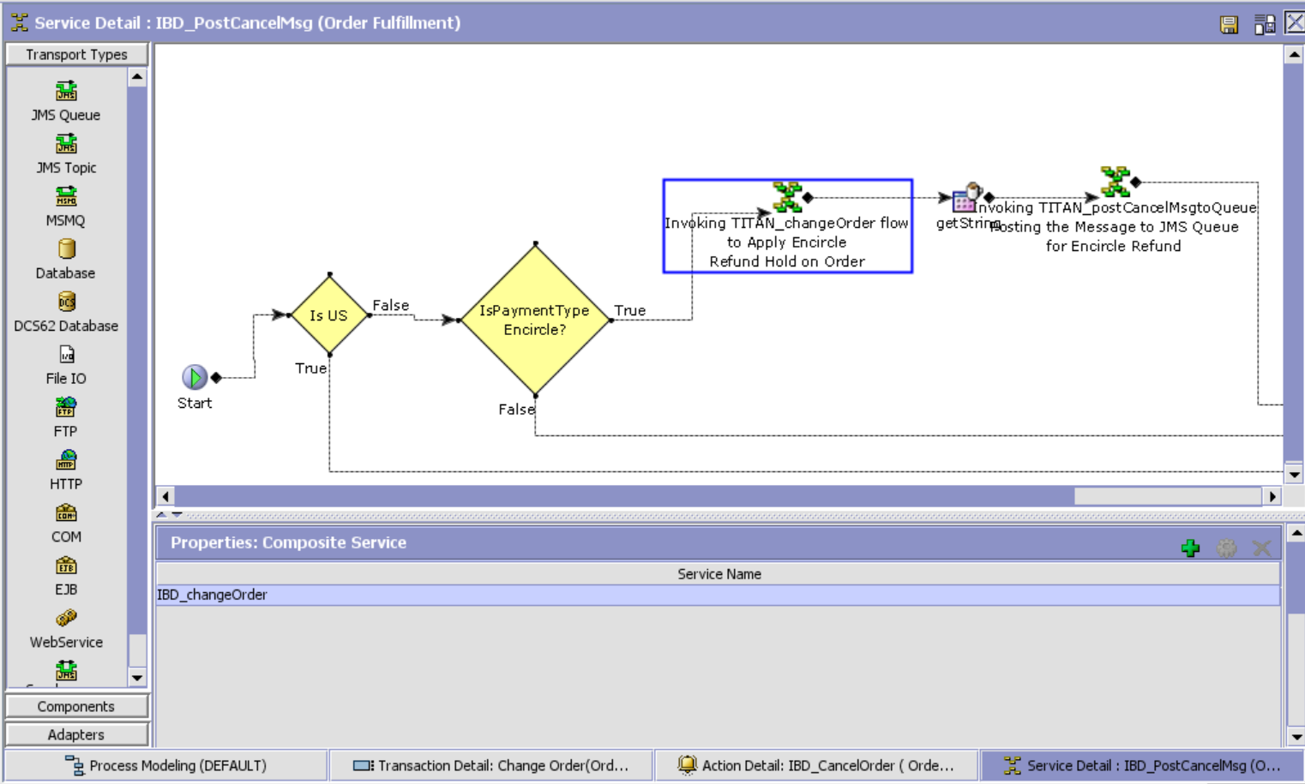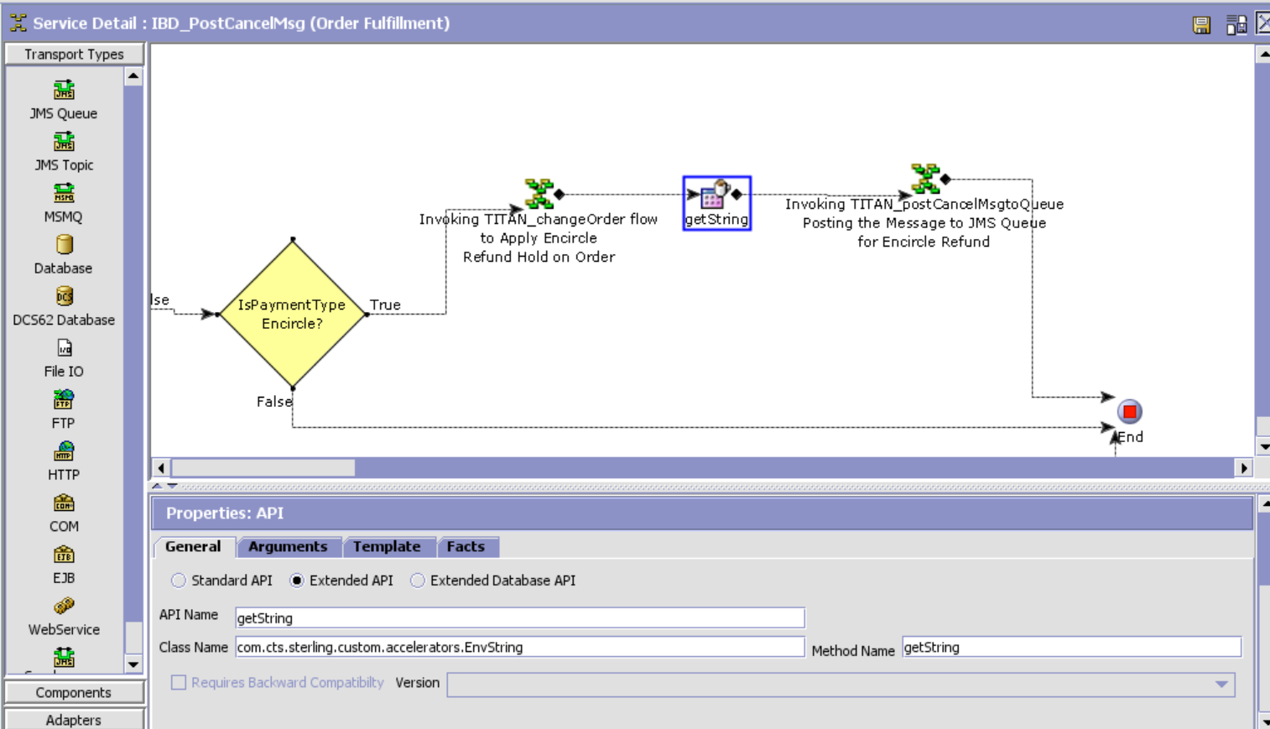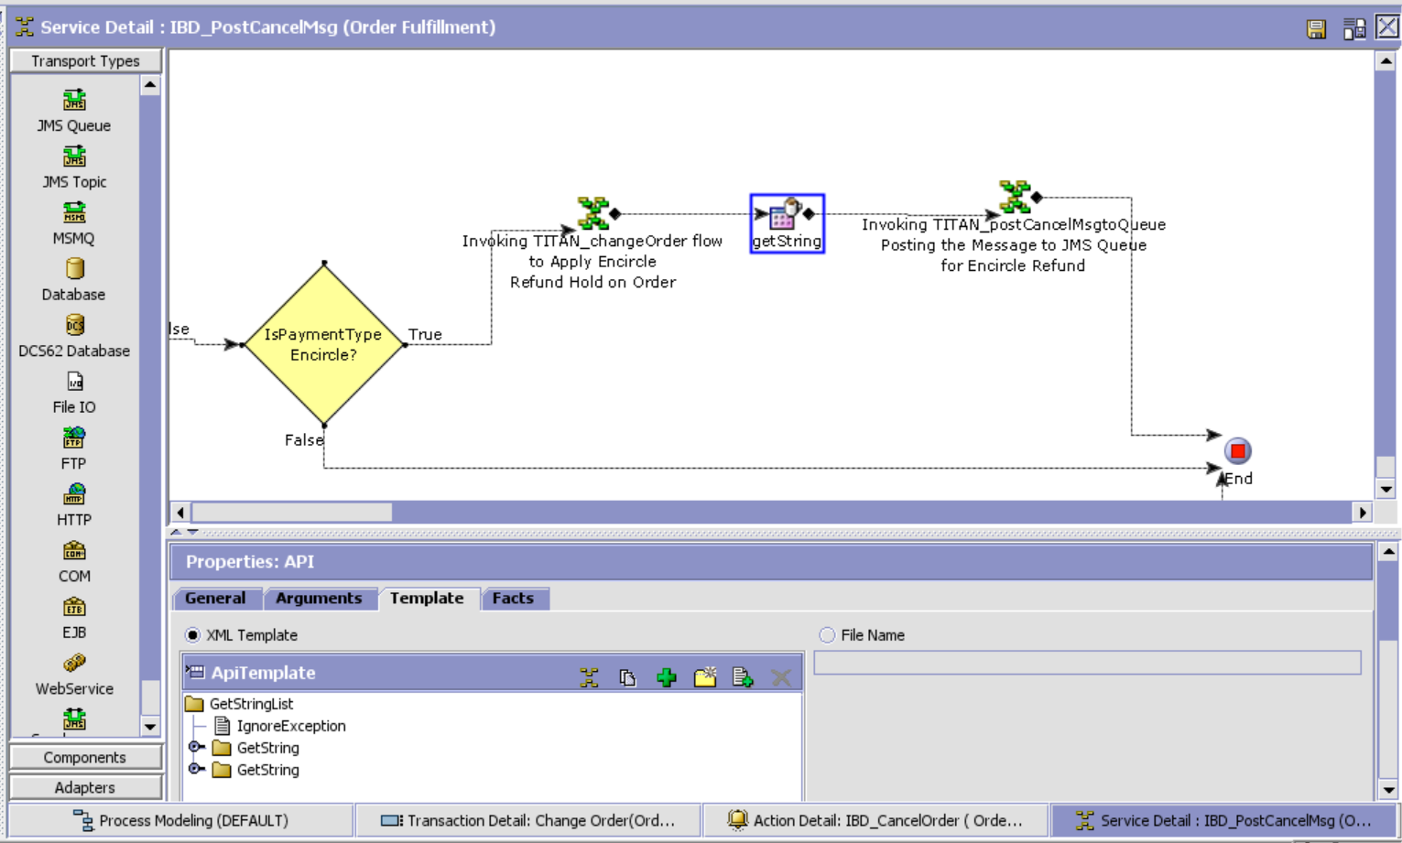

XSL Template:

<?xml version="1.0" encoding="UTF-8"?>

<GetStringList IgnoreException="Y">

<GetString AttributeName="FullOrderCancel" XpathToAppend="/Order"/>

<GetString AttributeName="PartialCancel" XpathToAppend="/Order"/>

</GetStringList>

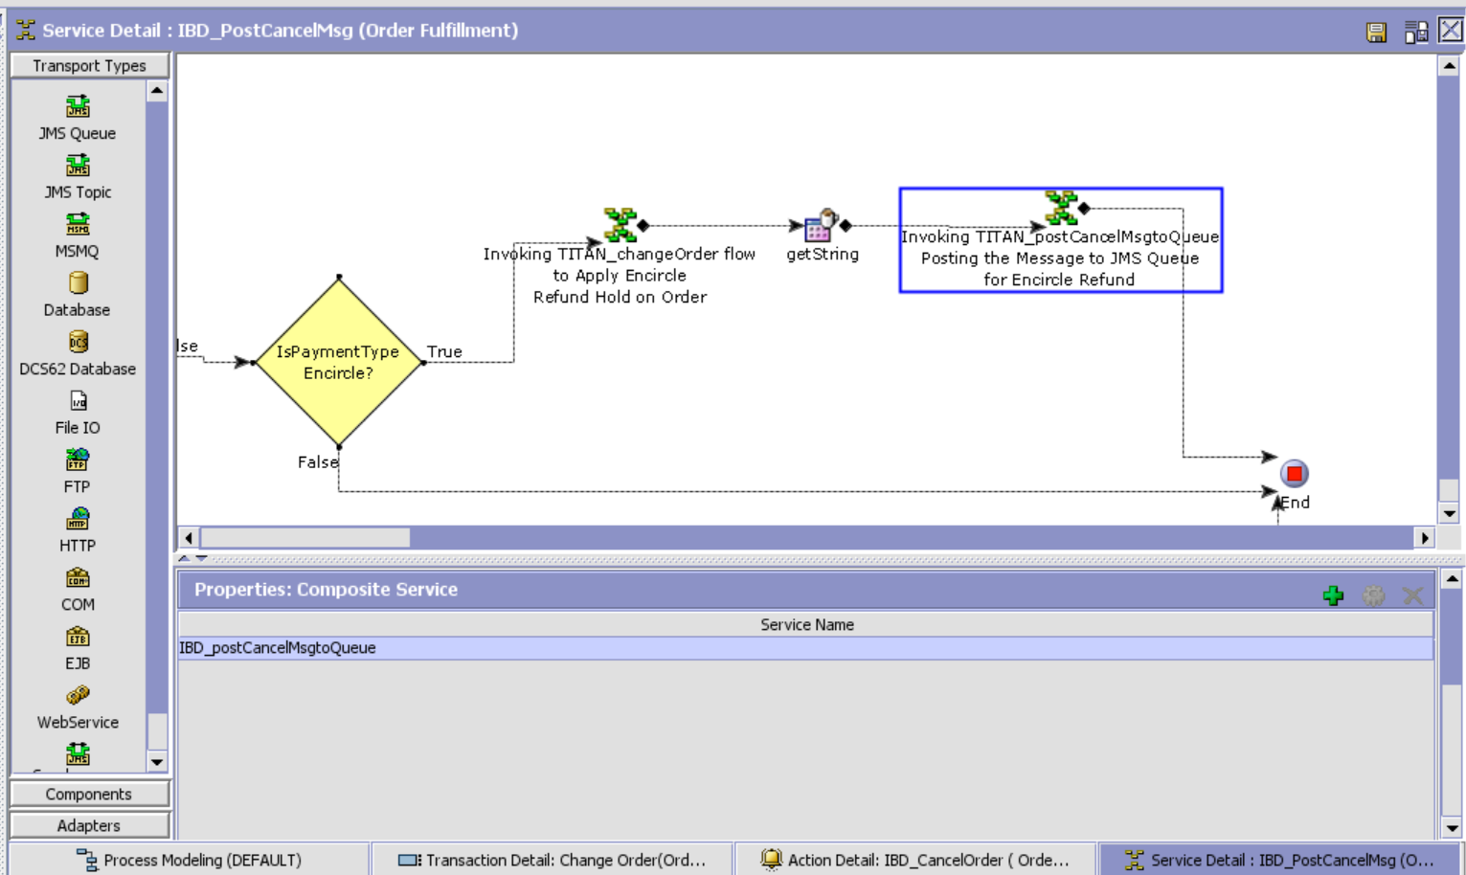

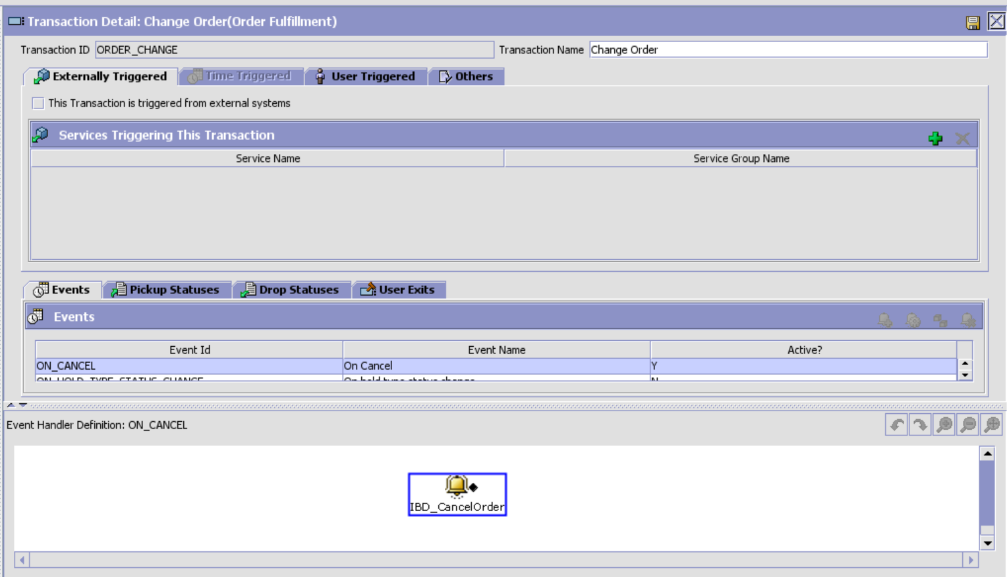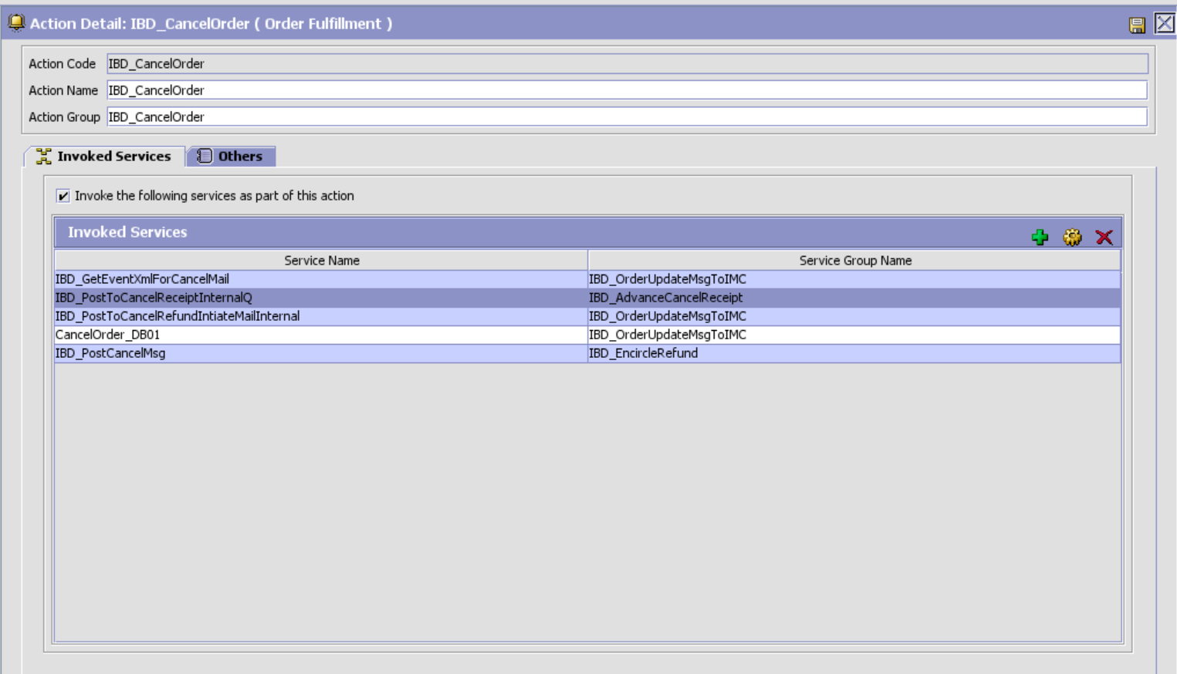

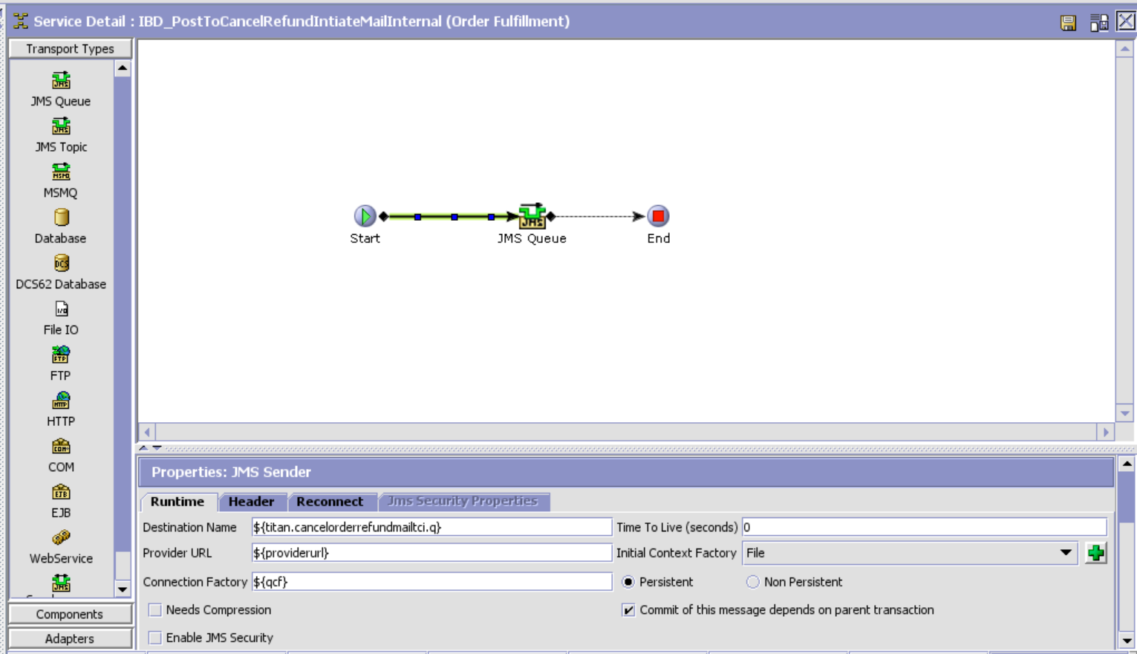

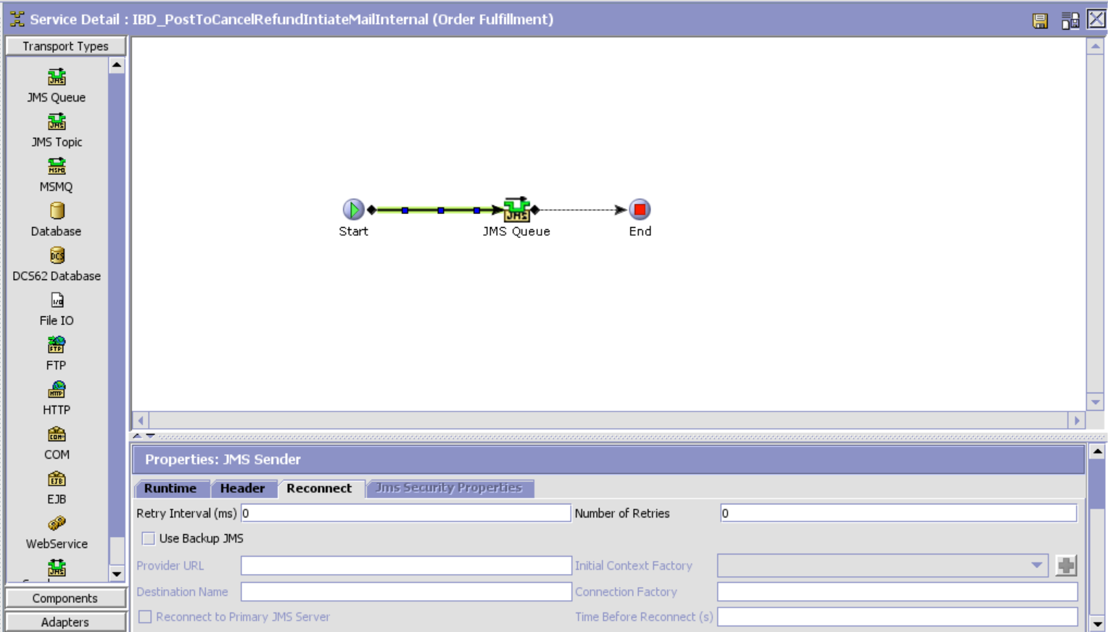

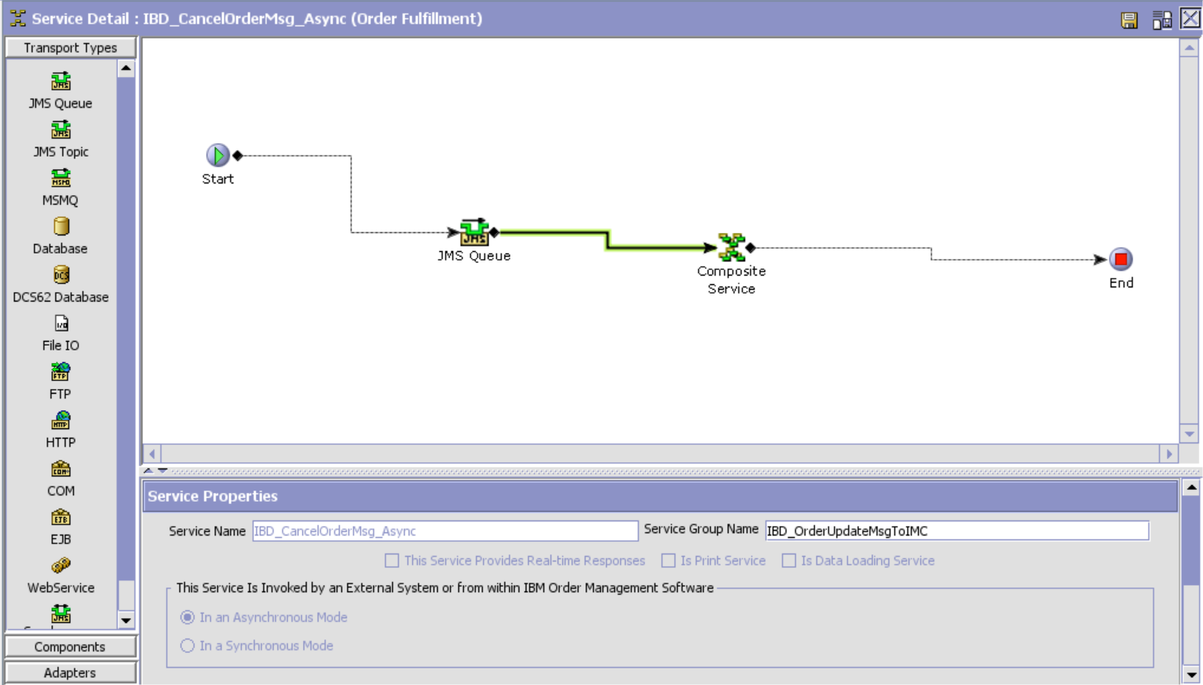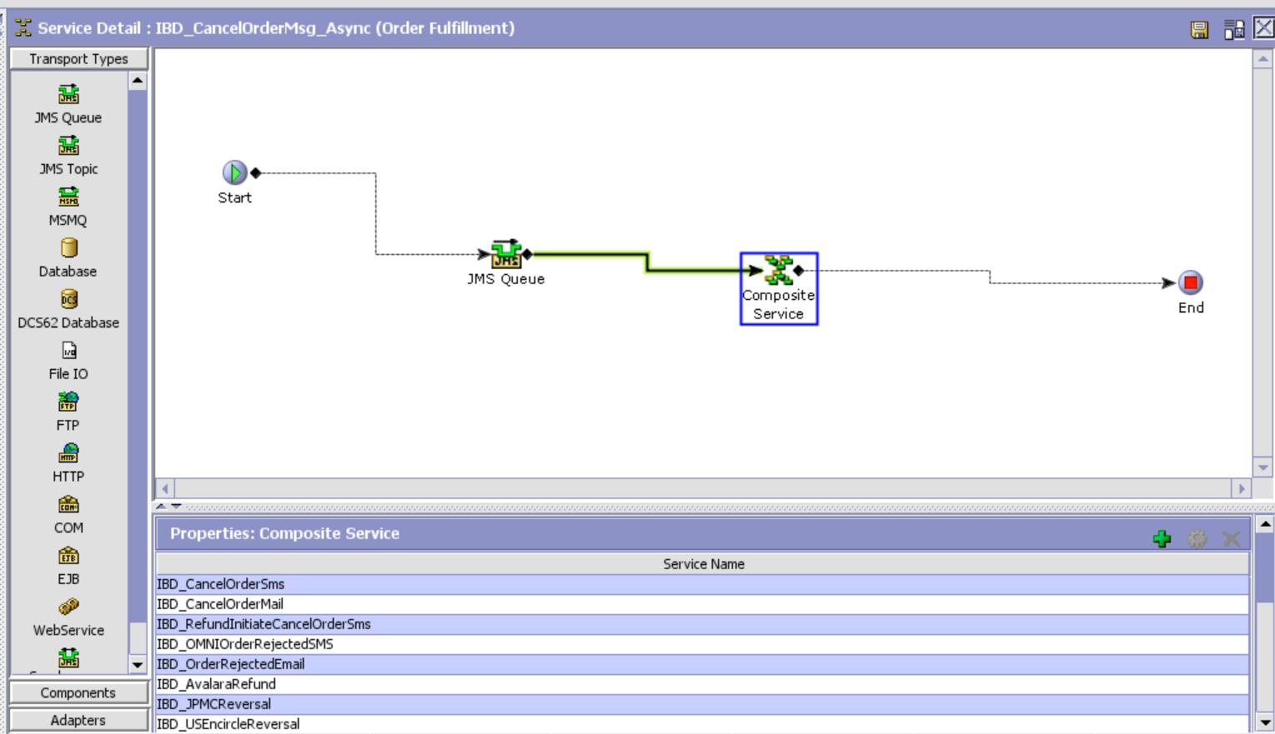

IBD_USEncircleReversal

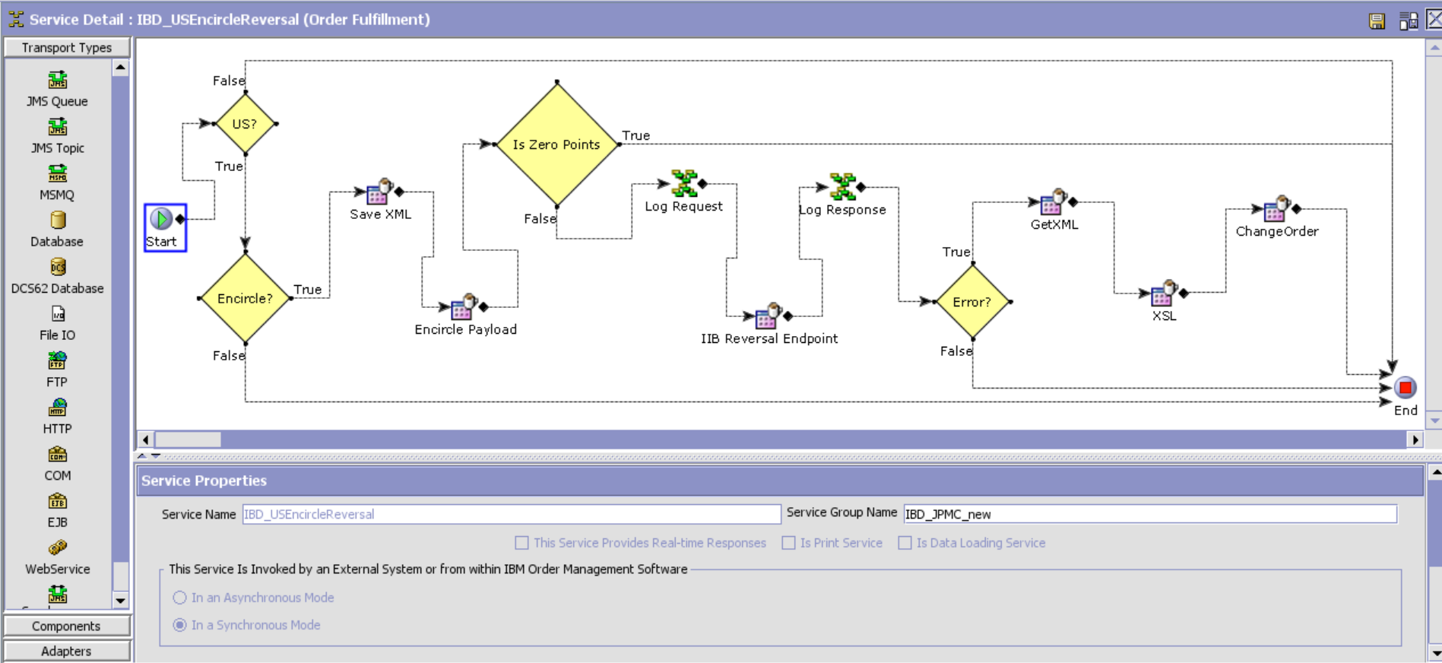

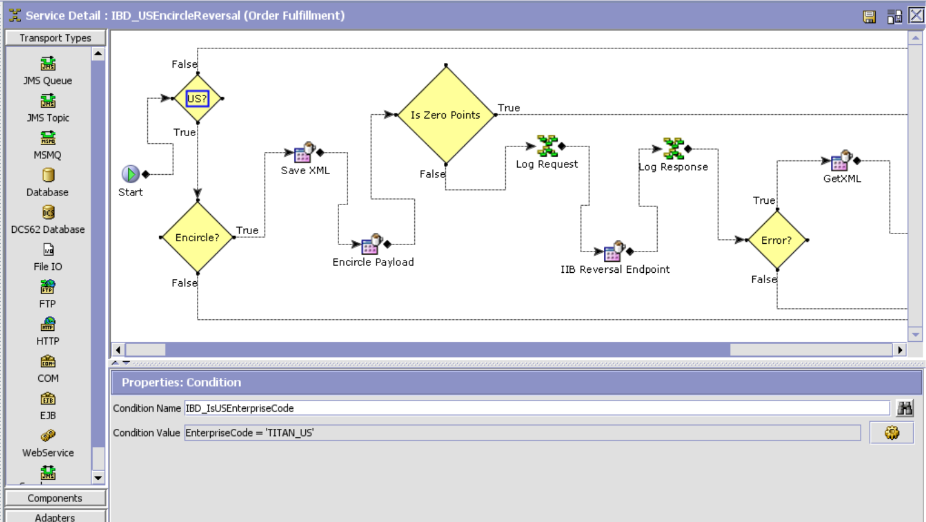

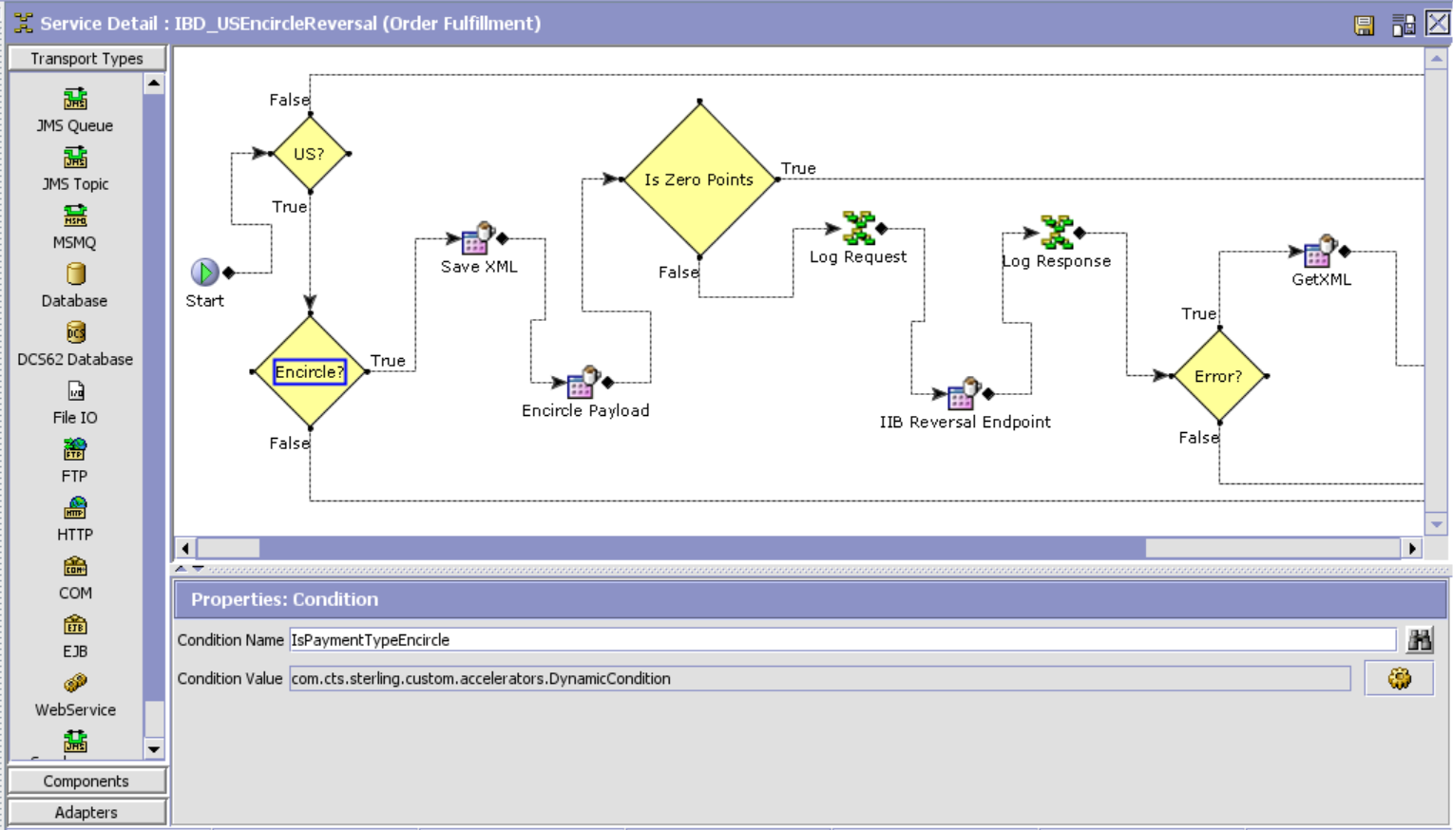

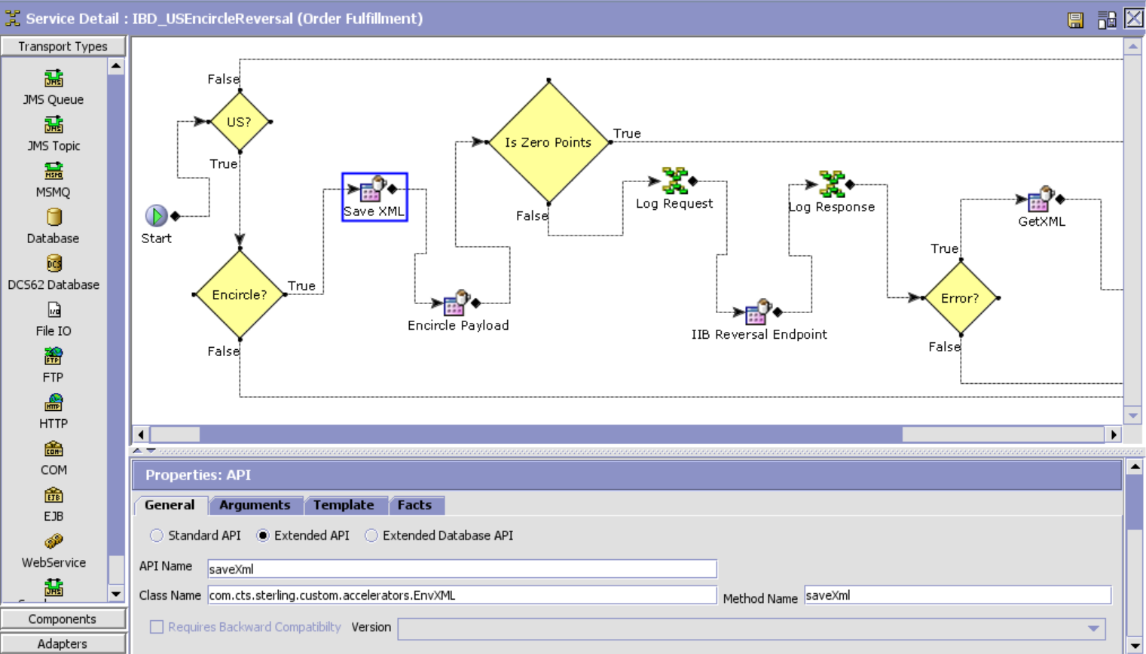

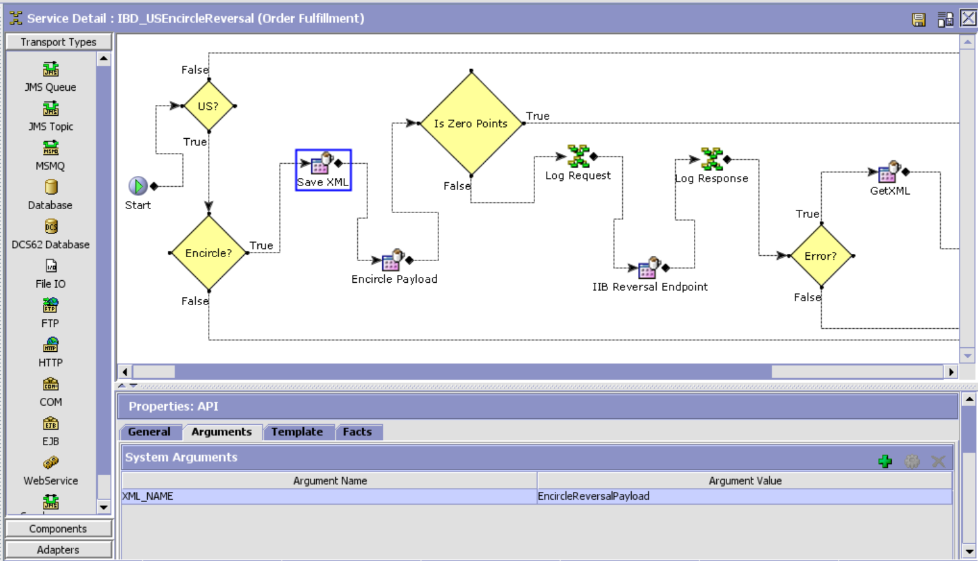

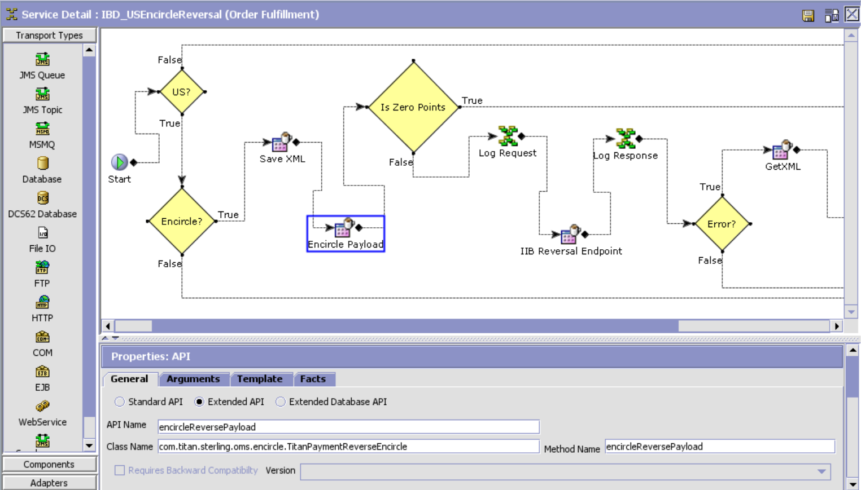

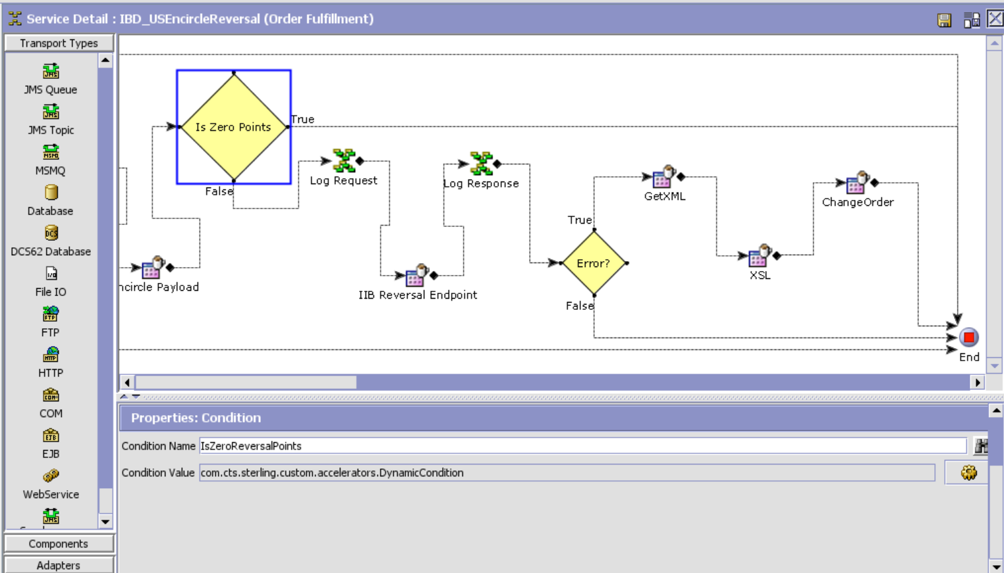

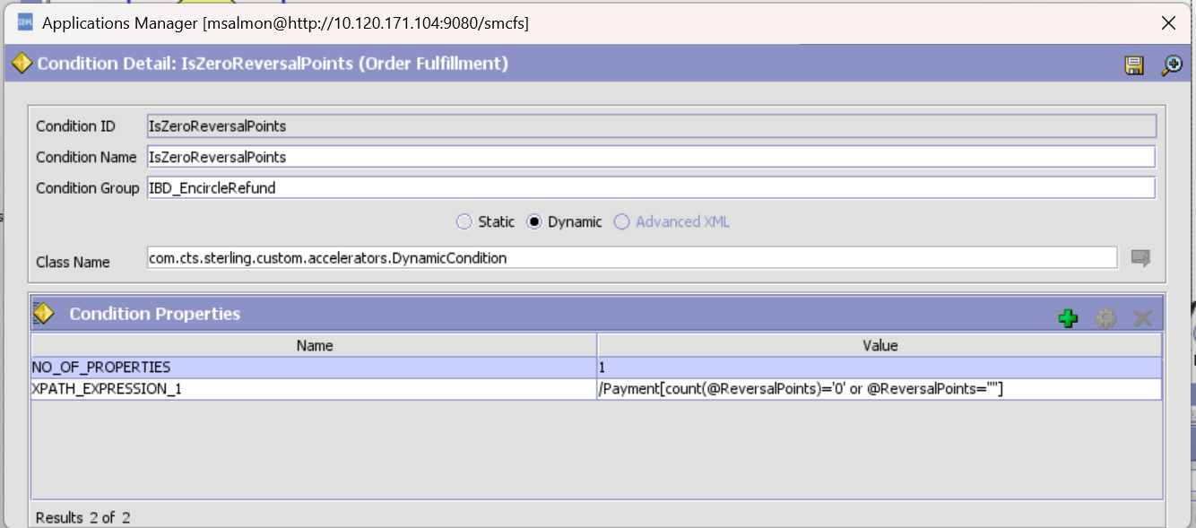

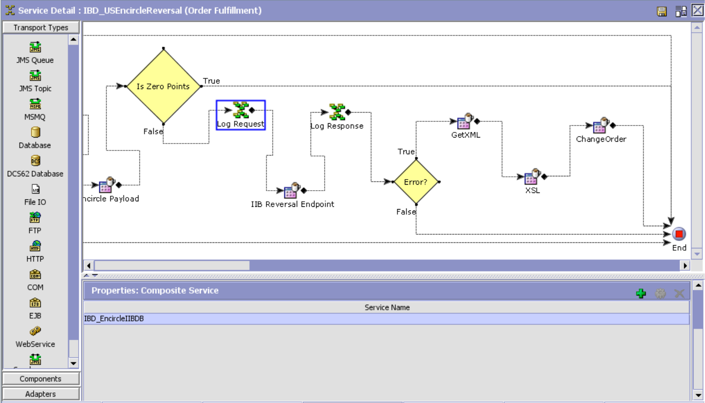

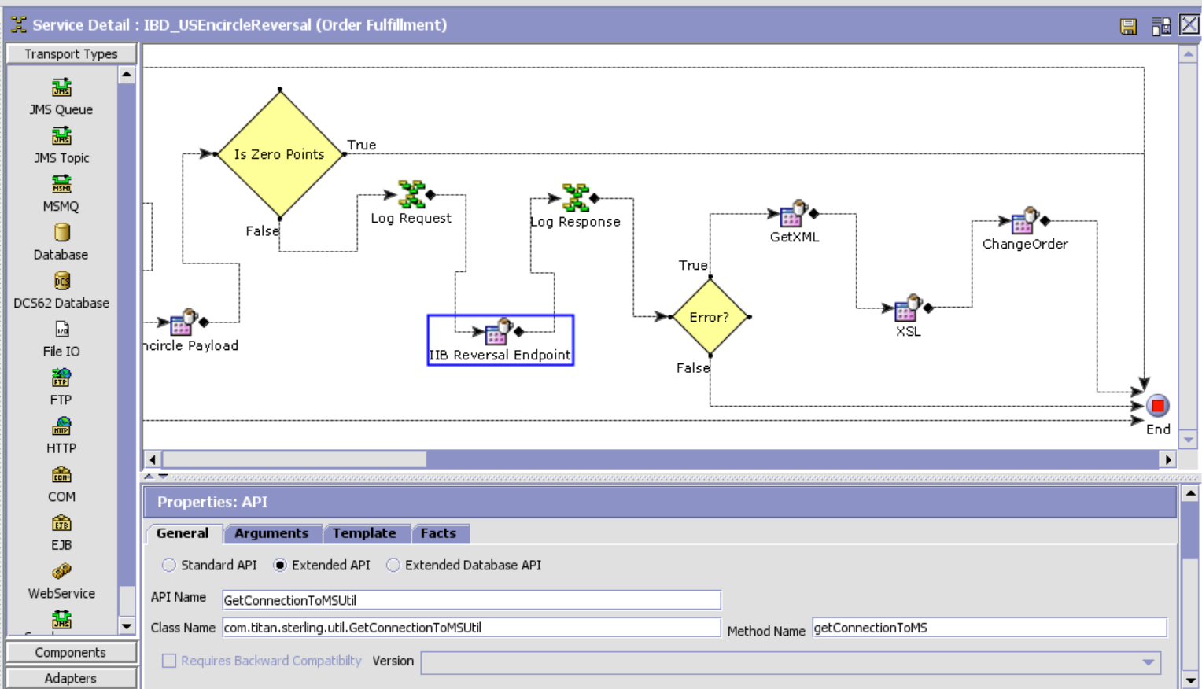

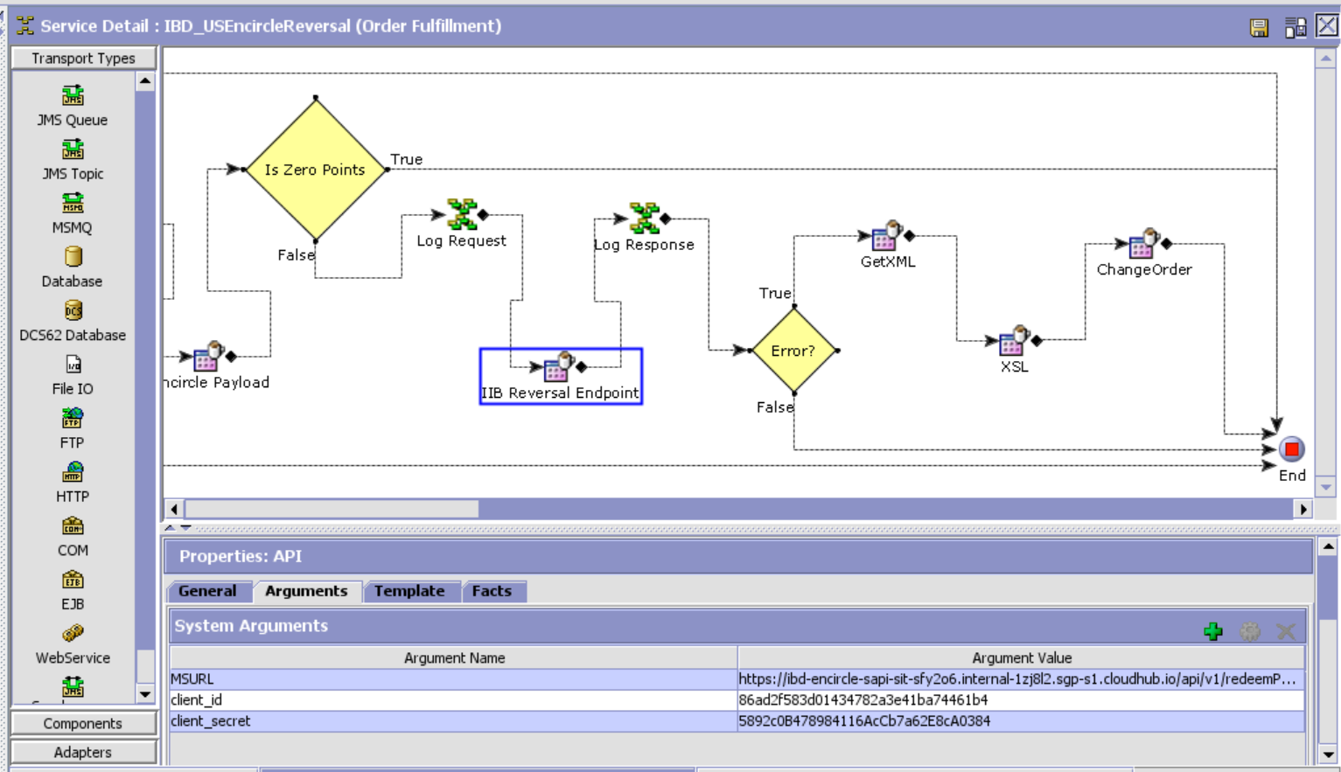

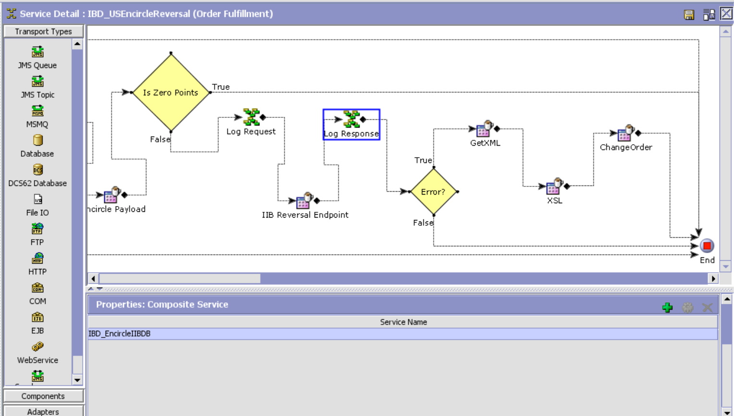

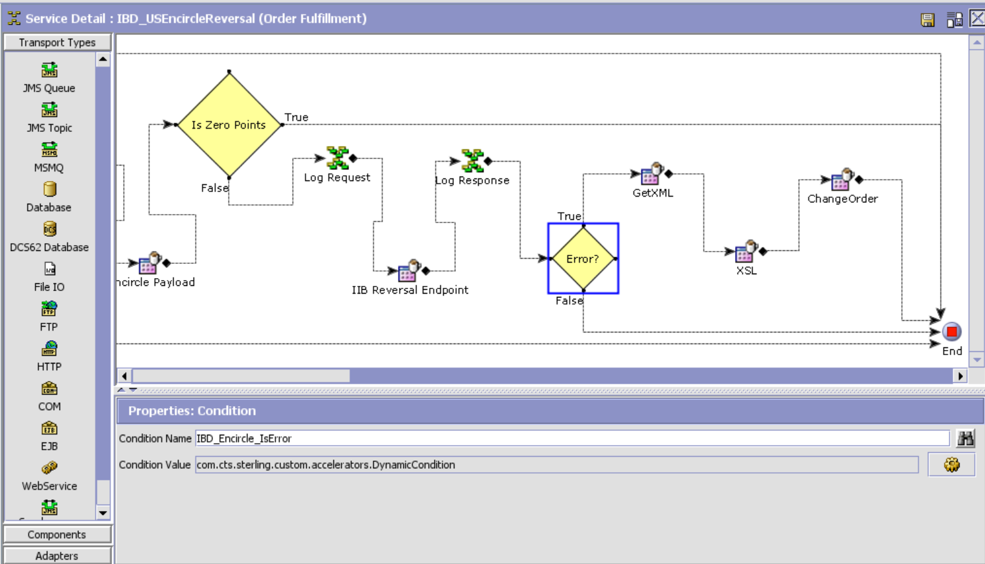

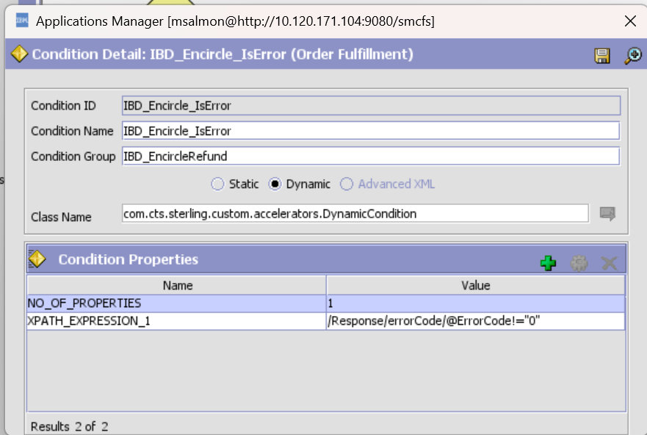

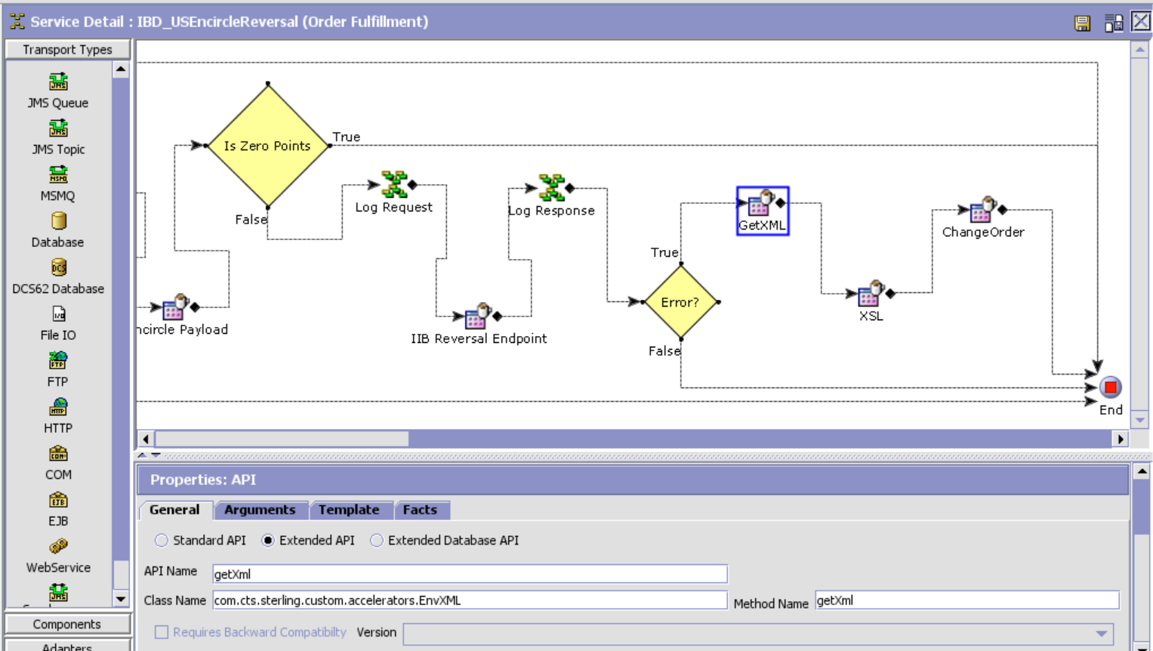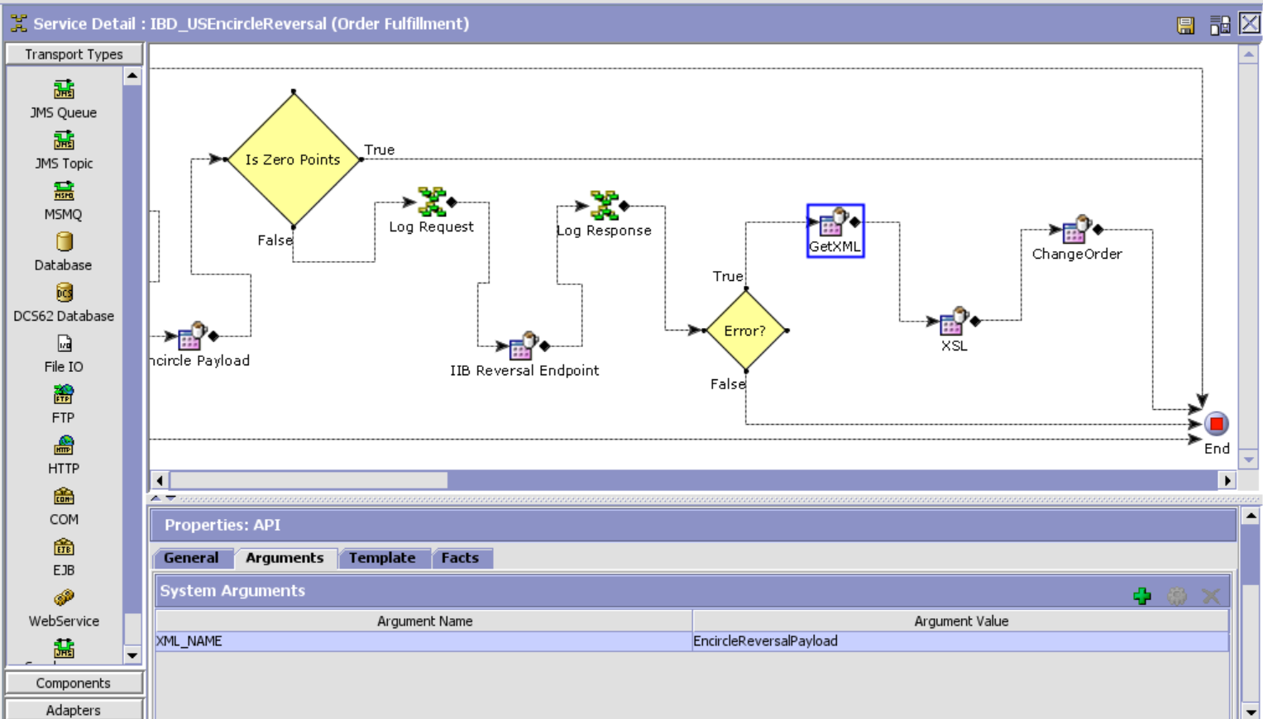

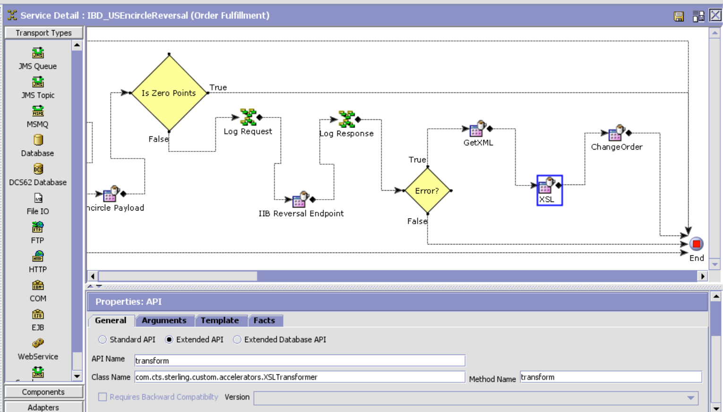XSL Template:

<?xml version="1.0" encoding="UTF-8"?>

<xsl:stylesheet version="1.0" xmlns:xsl="http://www.w3.org/1999/XSL/Transform">

<xsl:template match="/">

<xsl:element name="Order">

<xsl:attribute name="OrderNo">

<xsl:value-of select="Response/Order/@OrderNo"/>

</xsl:attribute>

<xsl:attribute name="Action">MODIFY</xsl:attribute>

<xsl:attribute name="DocumentType">0001</xsl:attribute>

<xsl:attribute name="EnterpriseCode">TITAN_US</xsl:attribute>

<xsl:attribute name="Override">Y</xsl:attribute>

<xsl:element name="OrderHoldTypes">

<xsl:element name="OrderHoldType">

<xsl:attribute name="HoldType">EN_REFUND_HOLD</xsl:attribute>

<xsl:attribute name="Status">1100</xsl:attribute>  
 </xsl:element>  
 </xsl:element>  
 </xsl:element>  
</xsl:template>

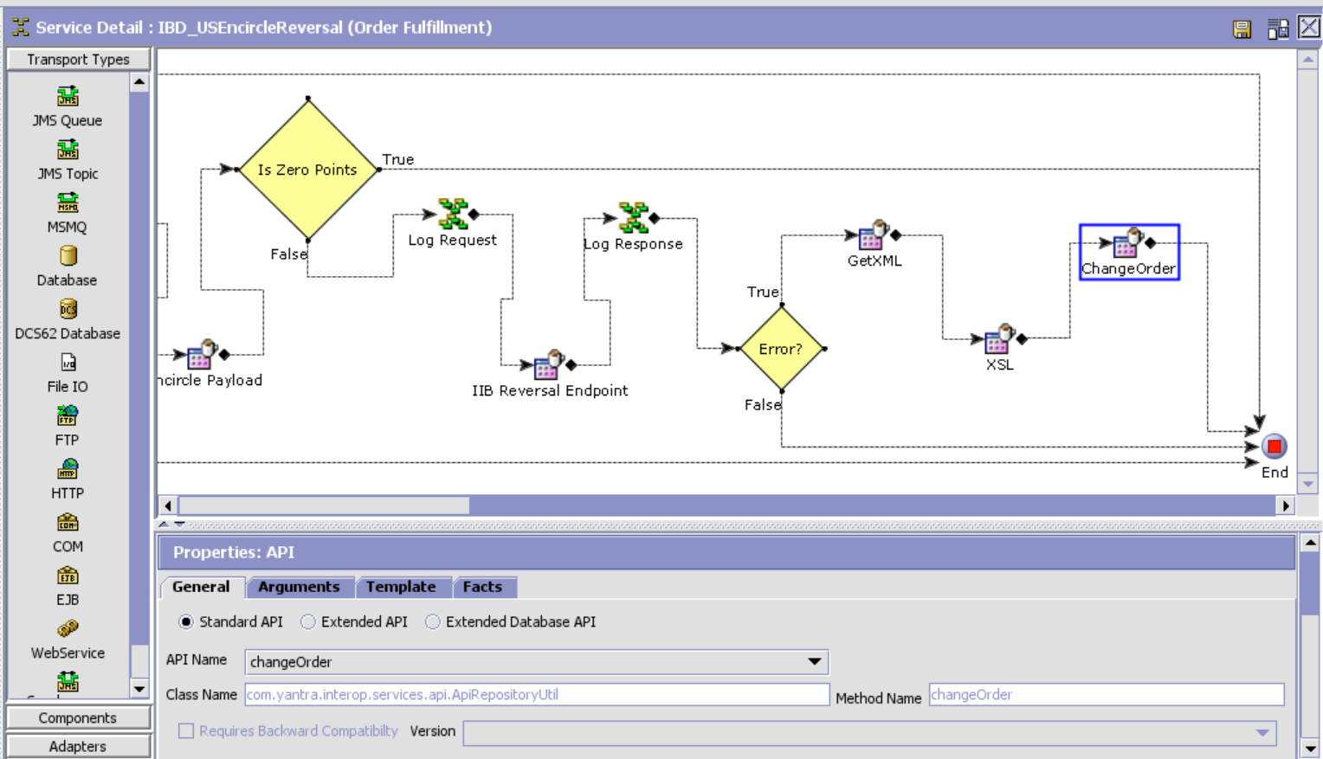

Encircle Refund

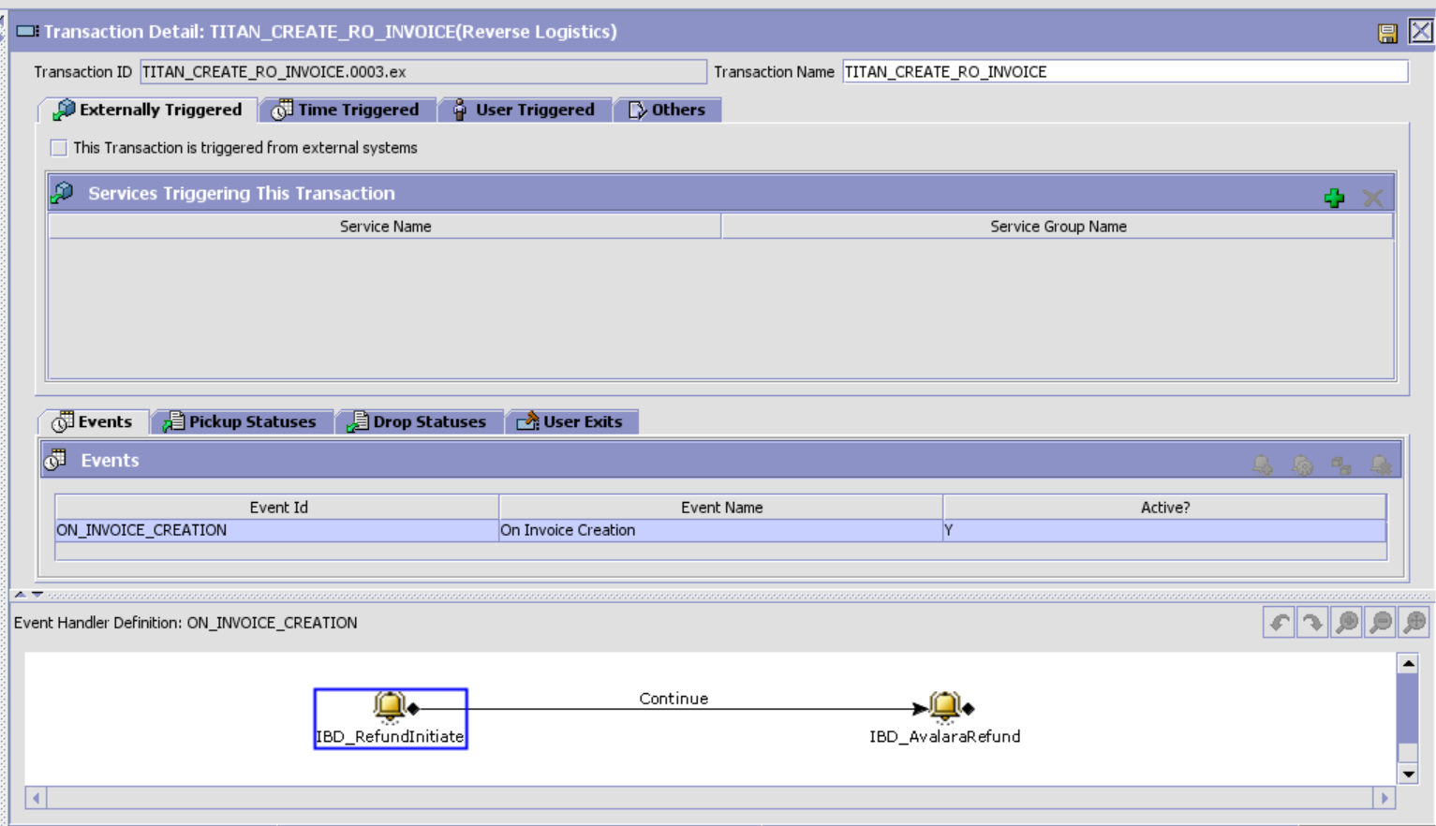

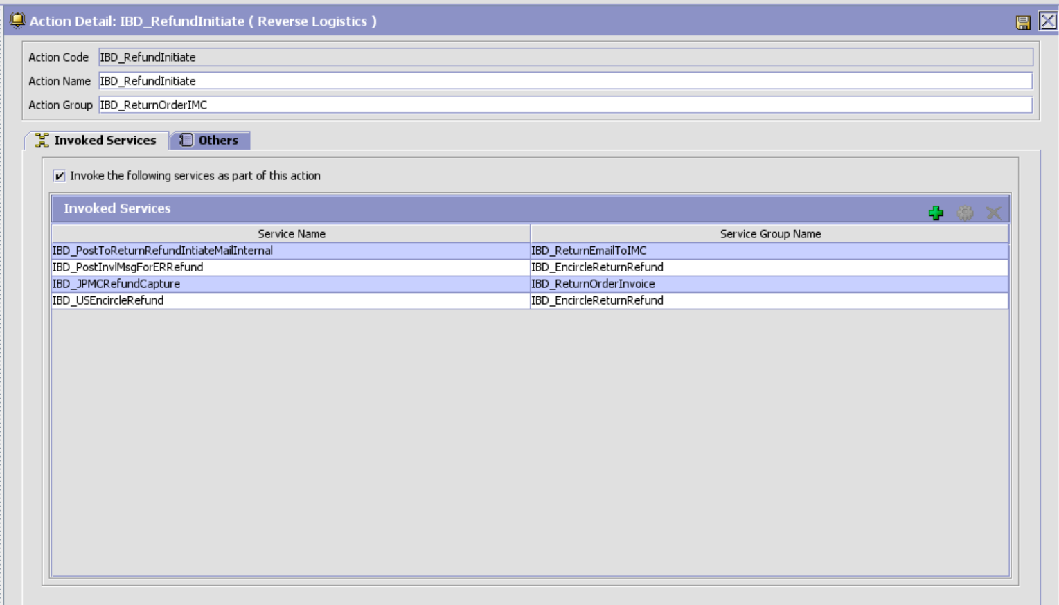

IBD_USEncircleRefund

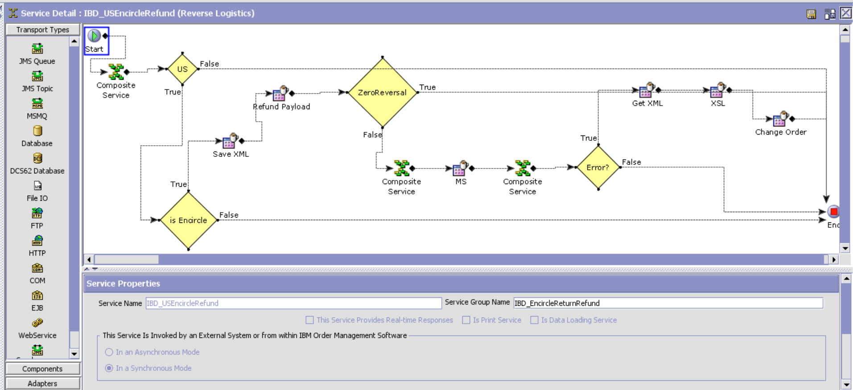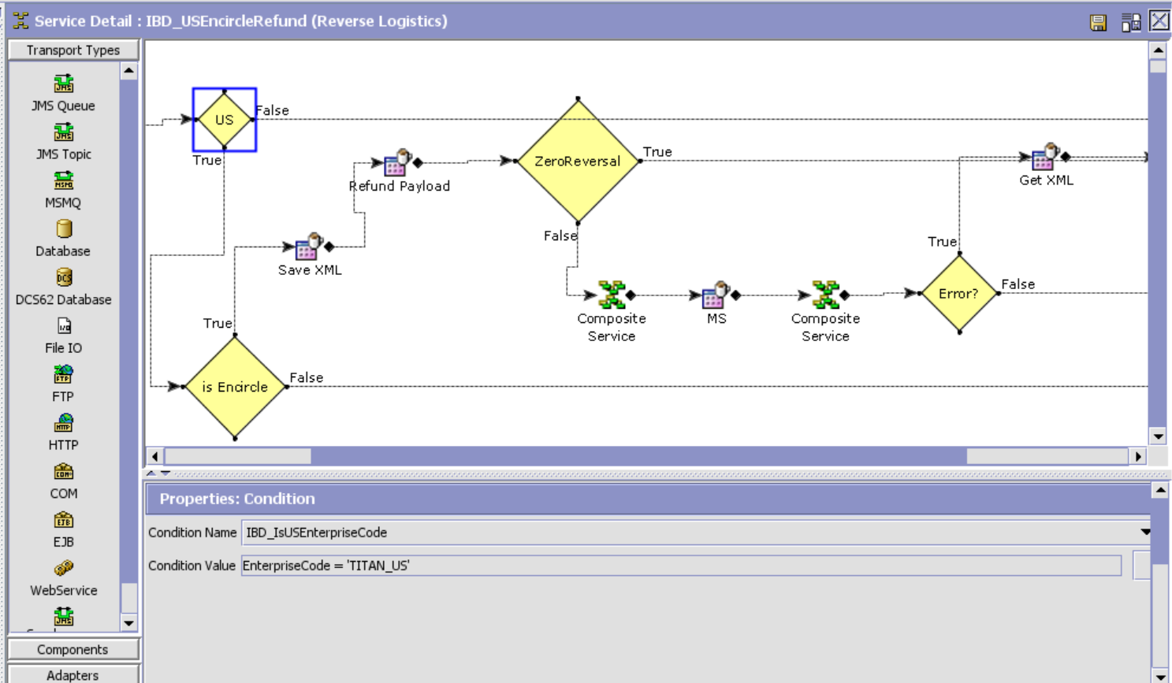

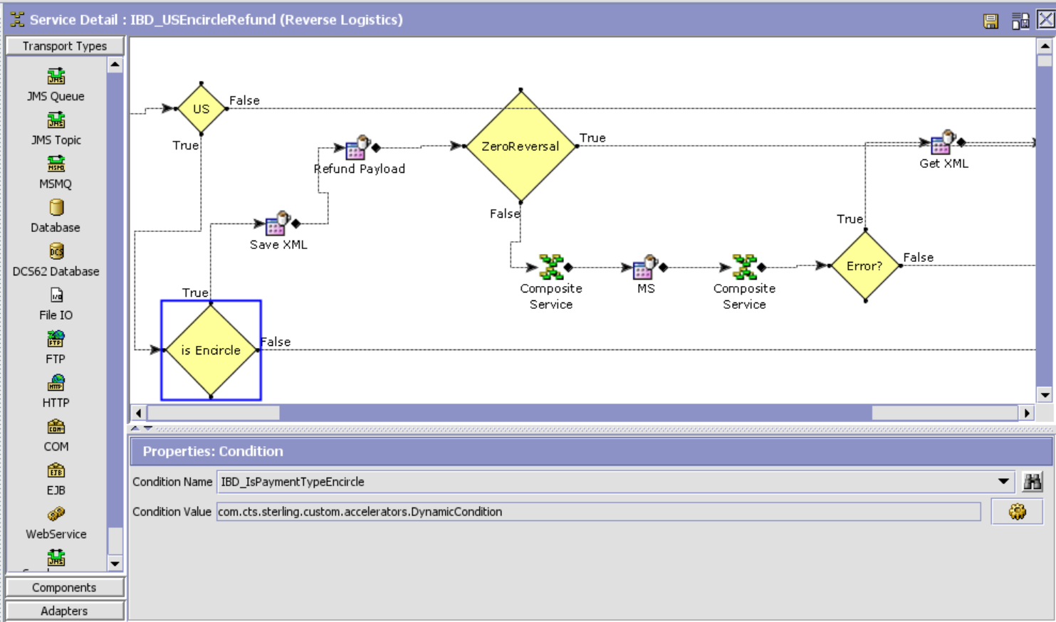

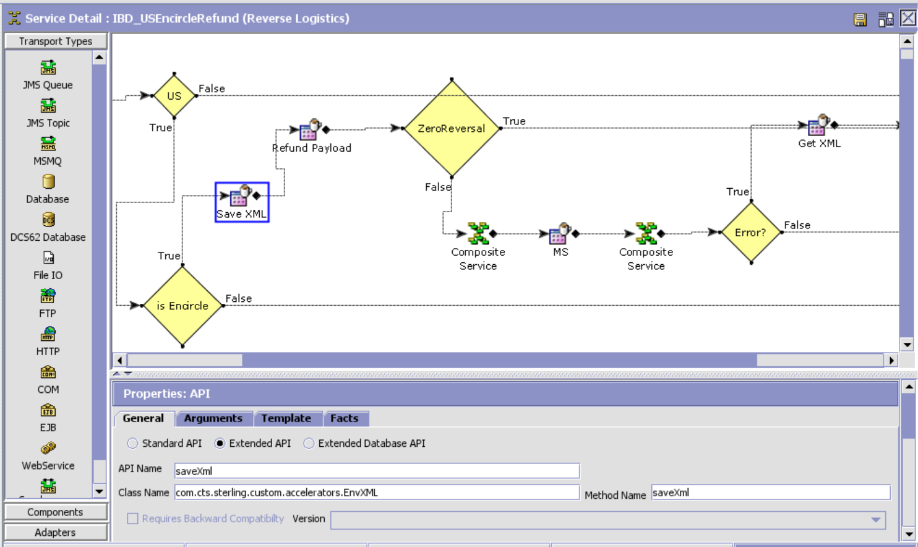

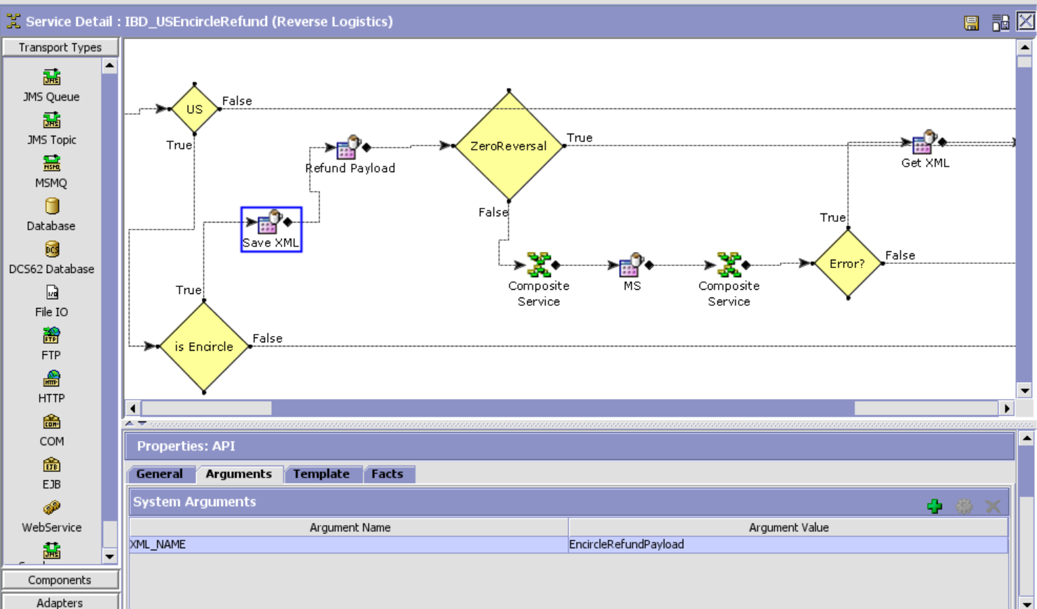

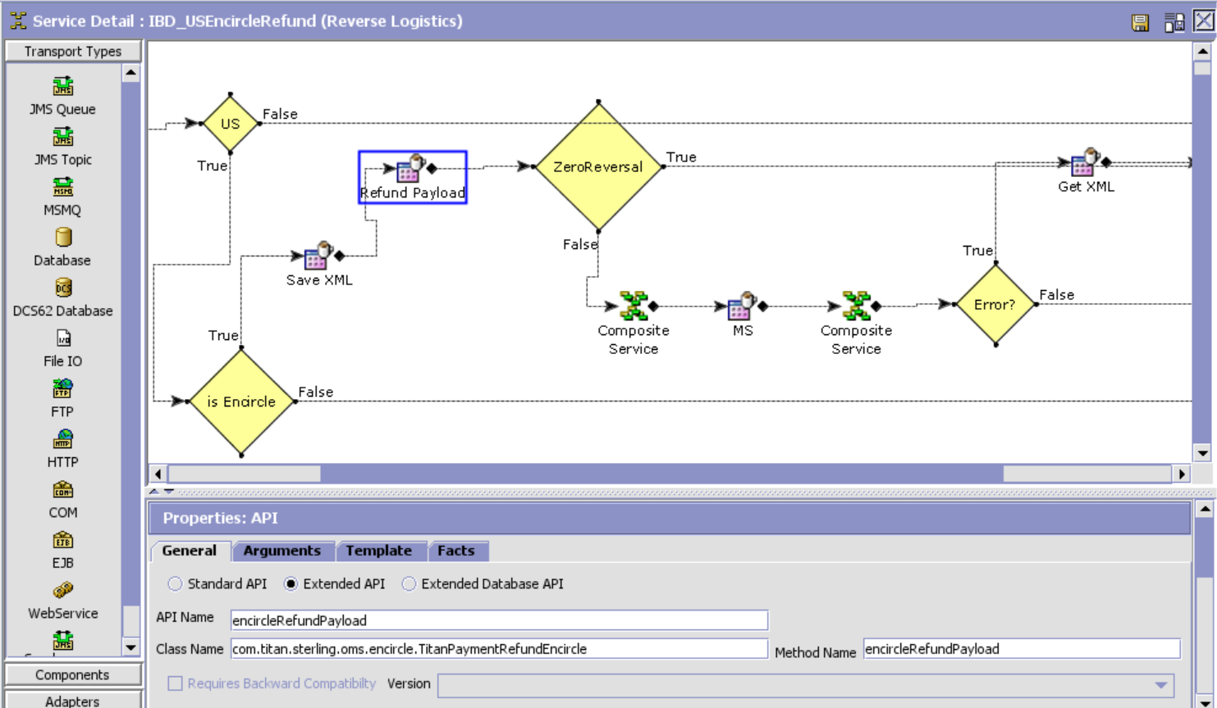

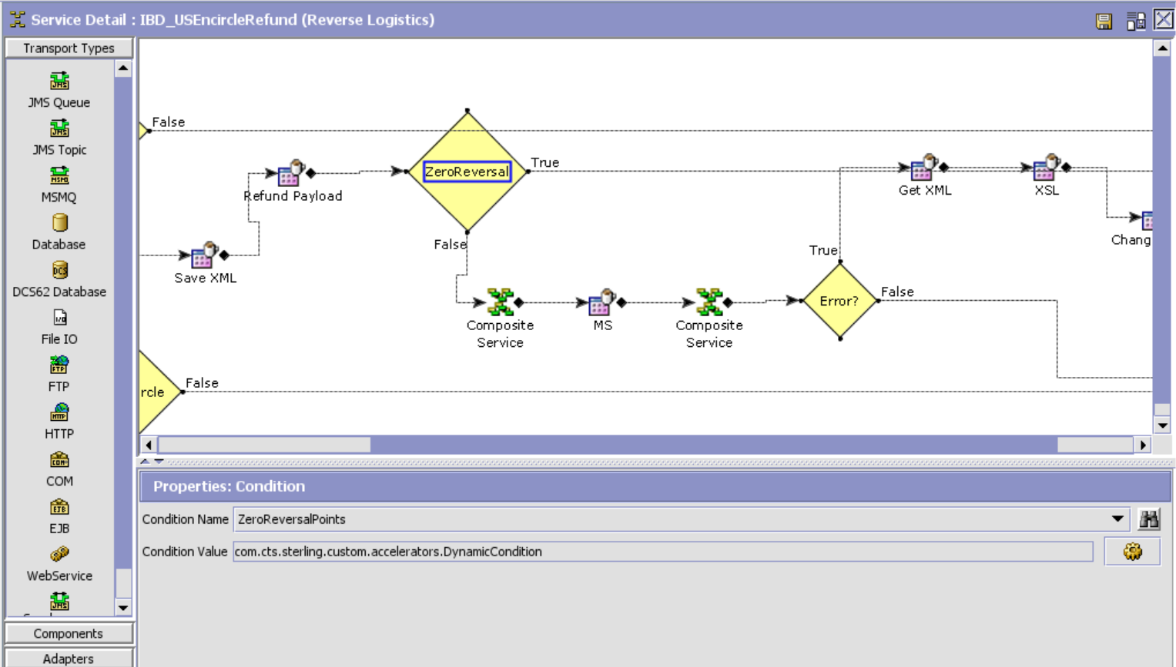

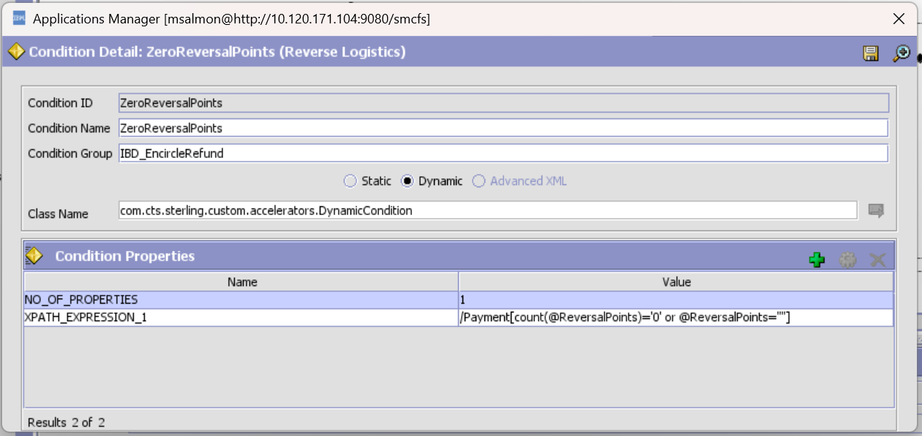

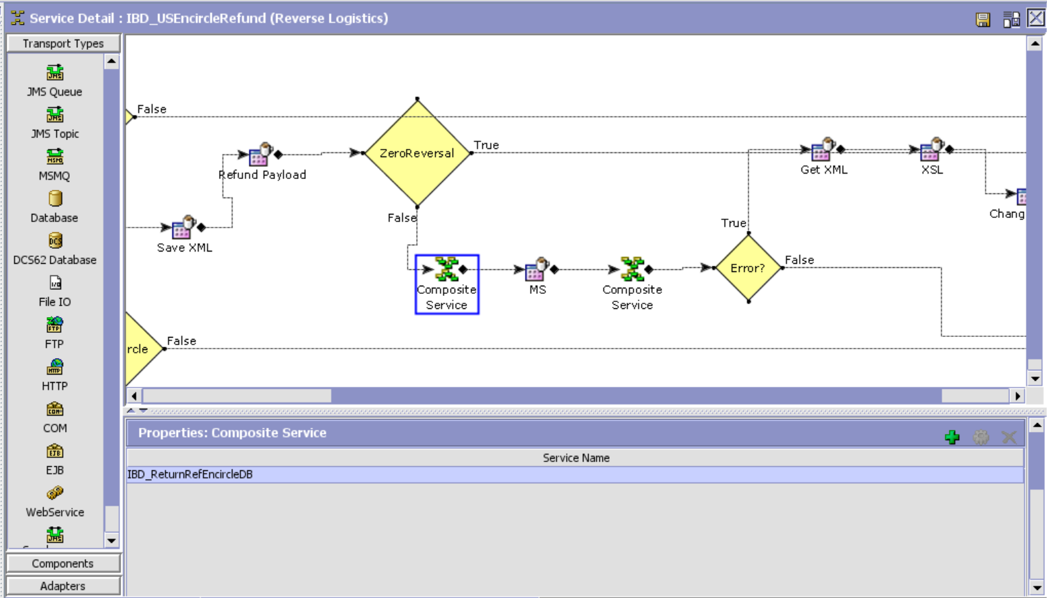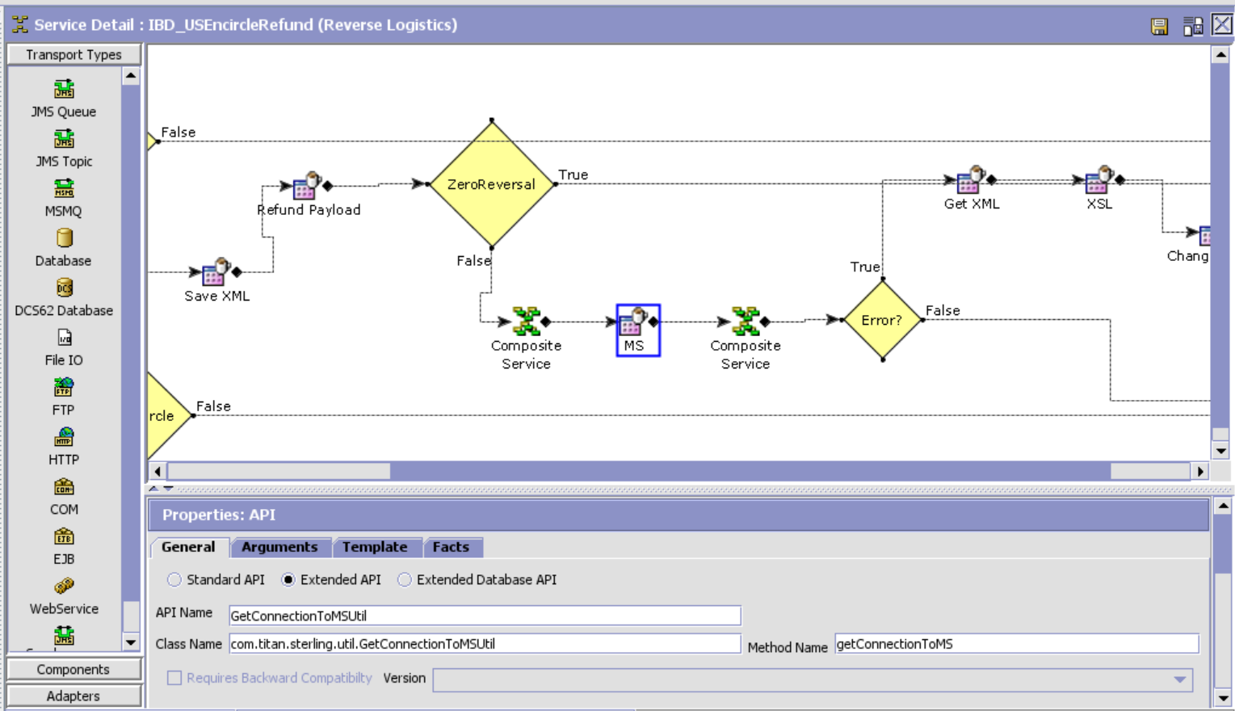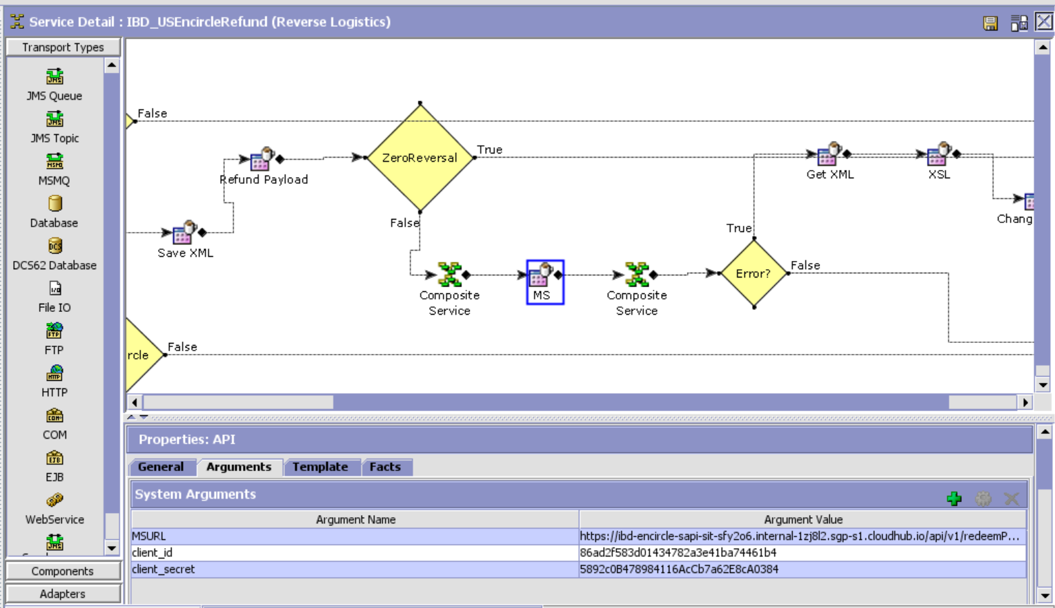

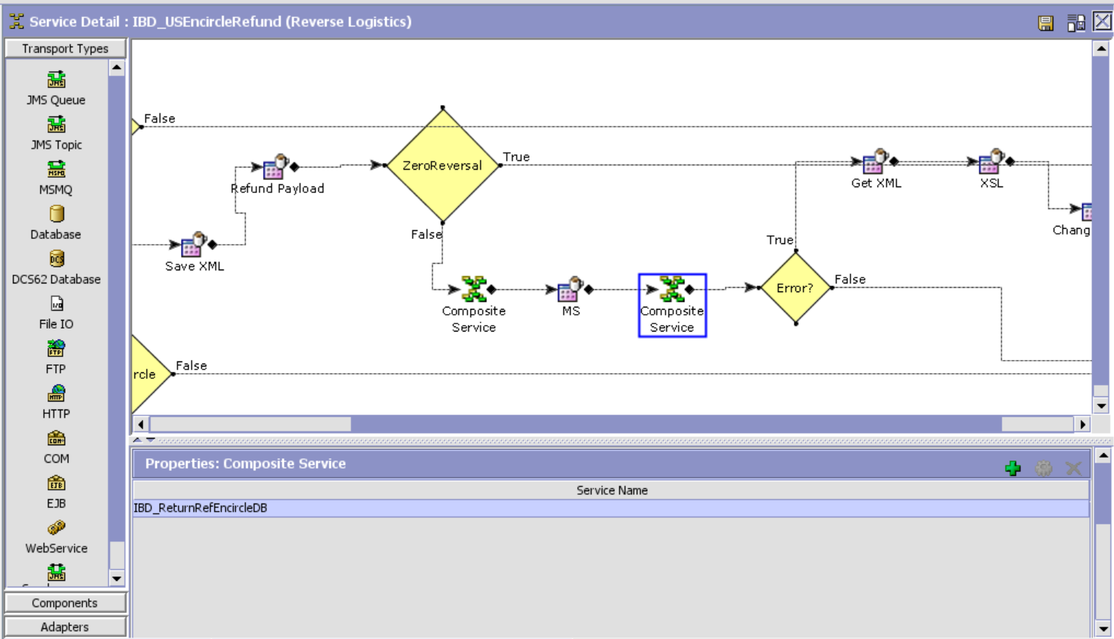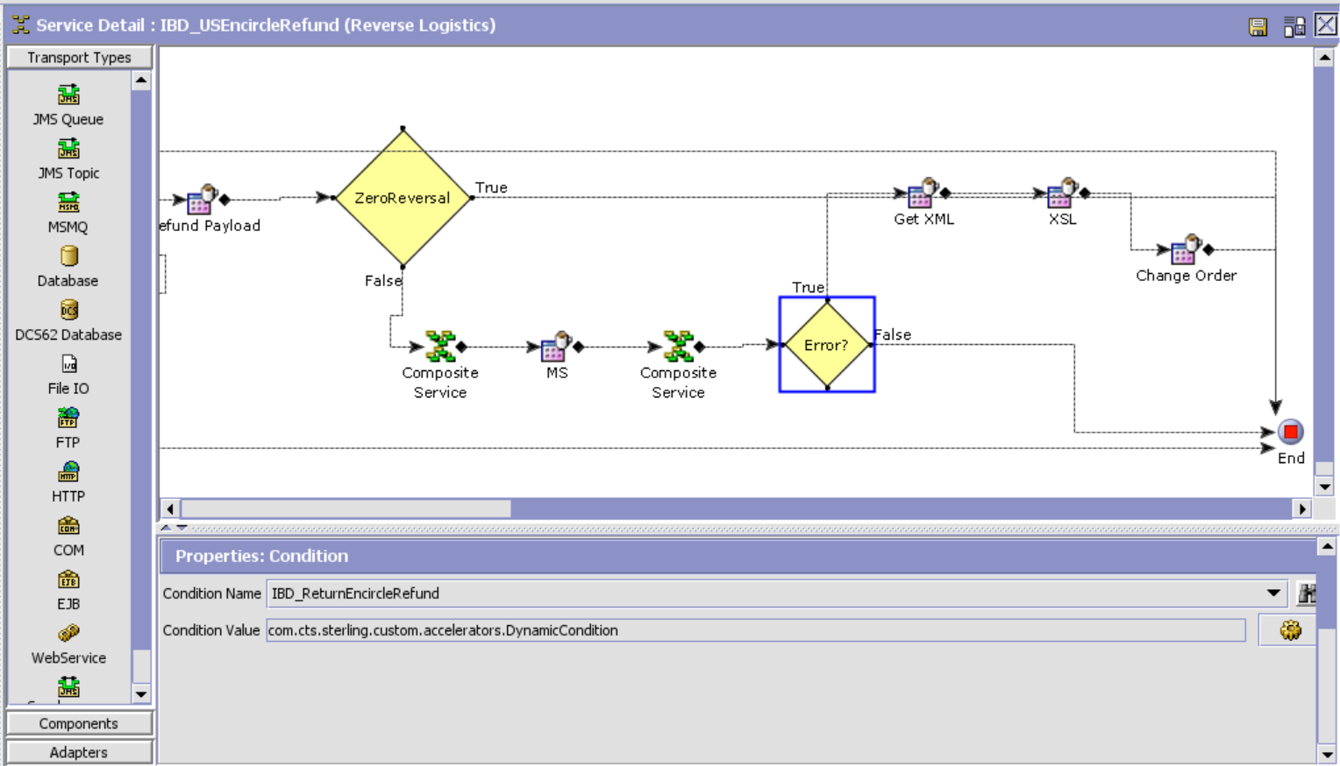

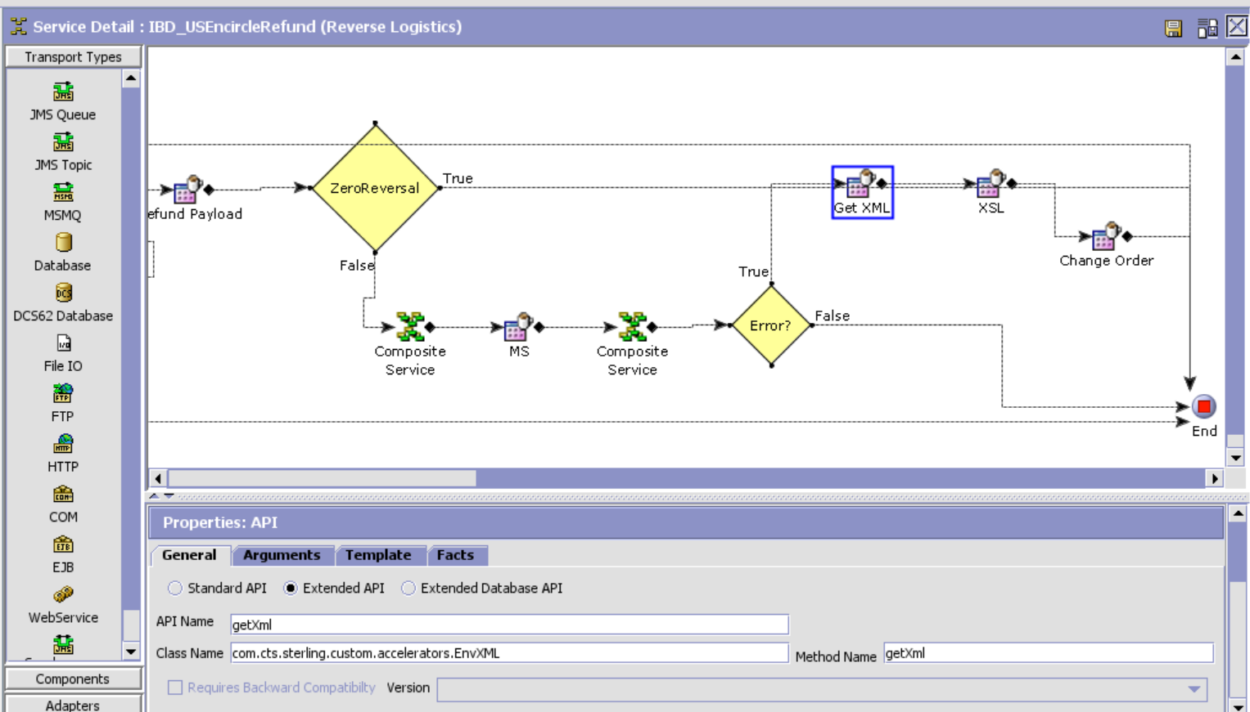

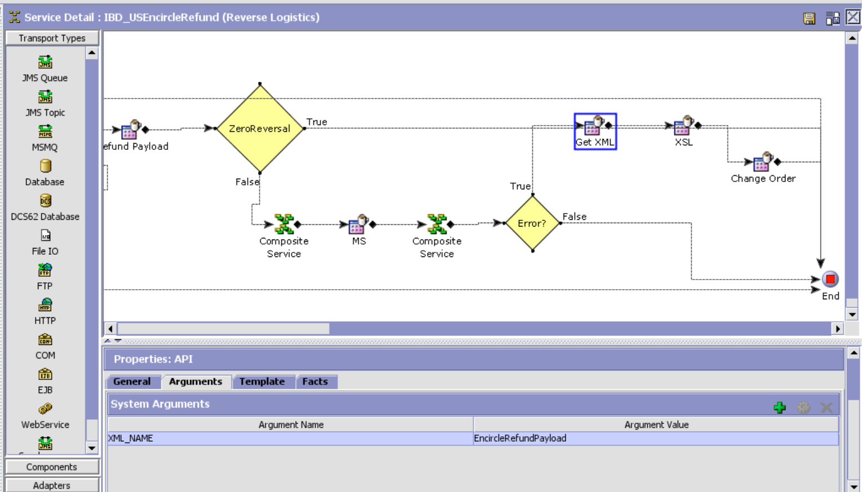

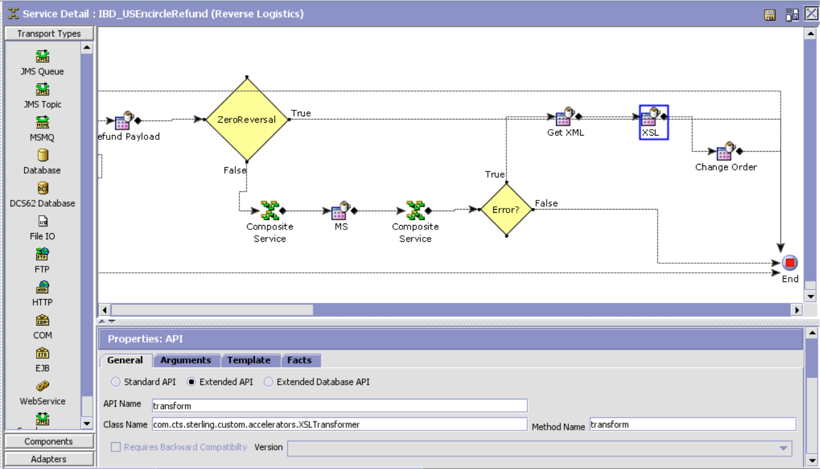XSL Template:

<xsl:stylesheet version="1.0" xmlns:xsl="http://www.w3.org/1999/XSL/Transform">

<xsl:template match="/">

<xsl:element name="Order">

<xsl:attribute name="OrderNo">

<xsl:value-of select="Response/Order/@OrderNo"/>

</xsl:attribute>

<xsl:attribute name="Action">MODIFY</xsl:attribute>

<xsl:attribute name="DocumentType">0001</xsl:attribute>

<xsl:attribute name="EnterpriseCode">TITAN_US</xsl:attribute>  
 <xsl:attribute name="Override">Y</xsl:attribute>  
 <xsl:element name="OrderHoldTypes">  
 <xsl:element name="OrderHoldType">  
 <xsl:attribute name="HoldType">EN_REFUND_HOLD</xsl:attribute>  
 <xsl:attribute name="Status">1100</xsl:attribute>  
 </xsl:element>

</xsl:element>  
 </xsl:element>  
</xsl:template>

